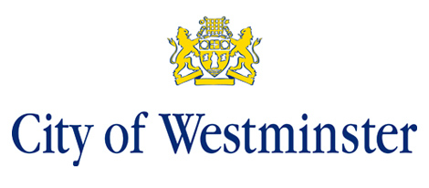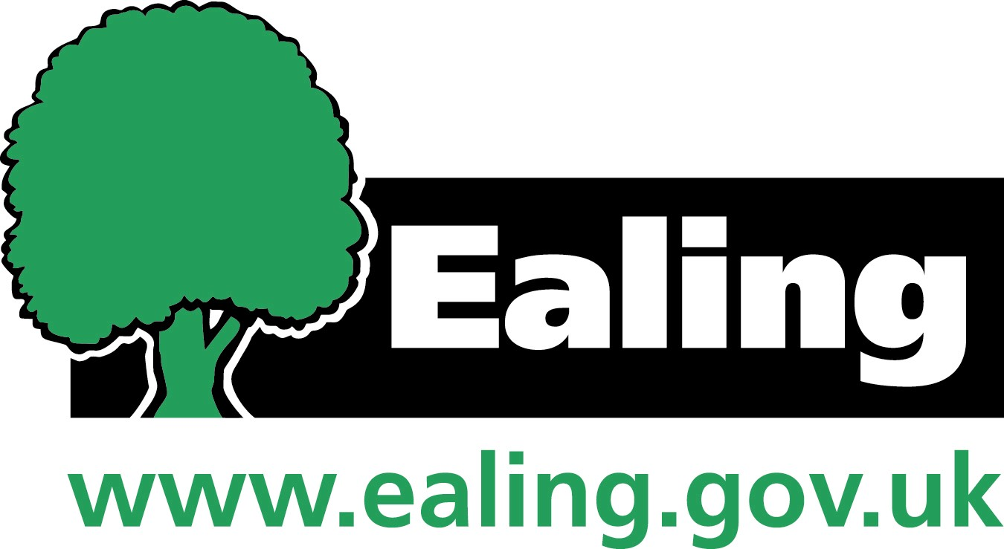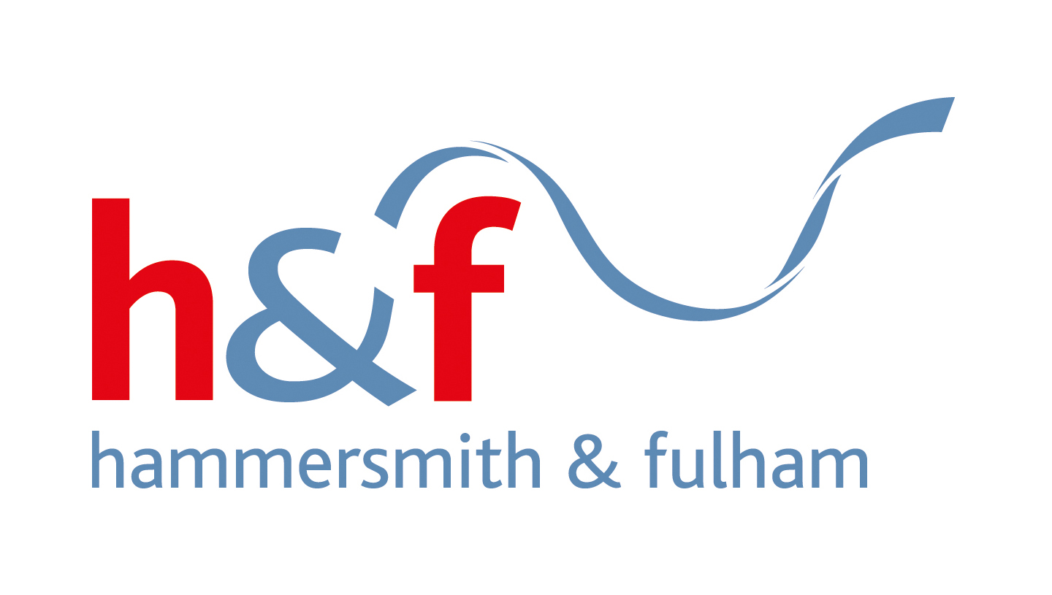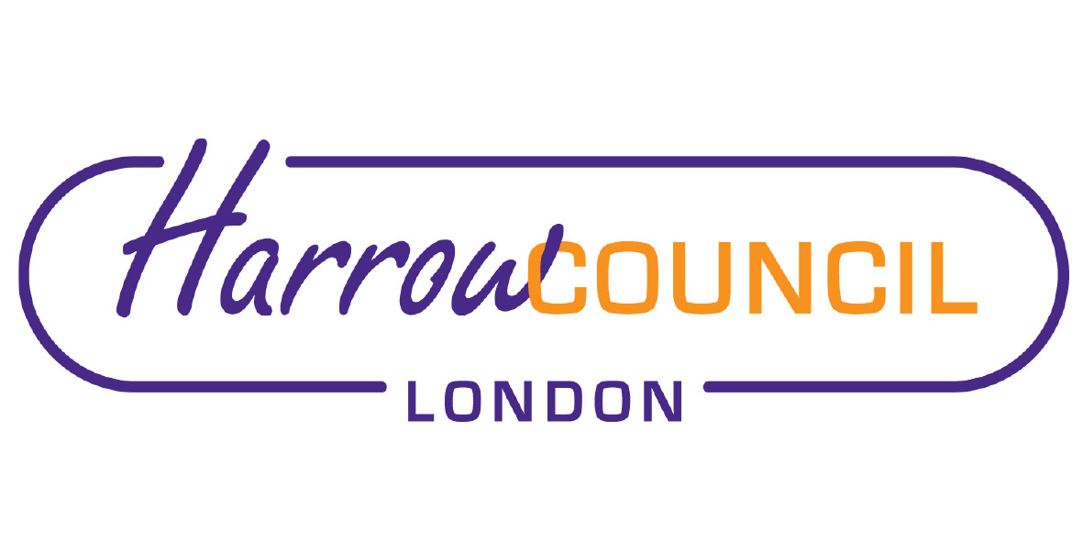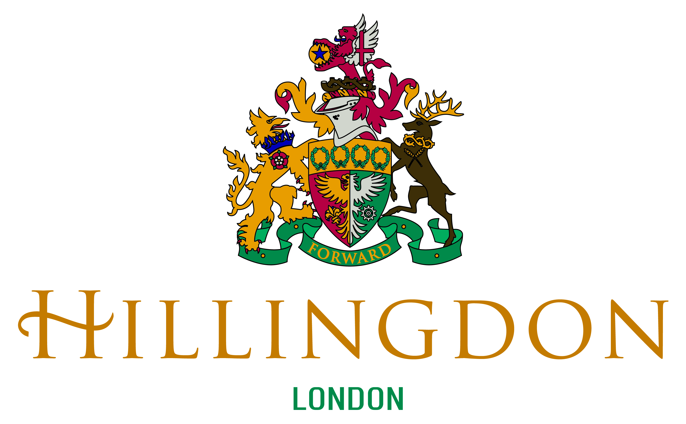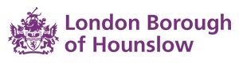

North West London
Clinical Commissioning Groups

Children and Young People’s Mental Health and Wellbeing Local Transformation Plan 2015-2020

October 2018 Refresh



Declarations of Support

Brent
Name:  Position/Organisation:  Date: | Name:  Position/Organisation:  Date:

Central London
Name:  Position/Organisation:  Date: | Name:  Position/Organisation:  Date

Ealing
Name:  Position/Organisation:  Date: | Name:  Position/Organisation:  Date:

Hammersmith and Fulham
Name:  Position/Organisation:  Date: | Name:  Position/Organisation:  Date:

Harrow
Name:  Position/Organisation:  Date: | Name:  Position/Organisation: Chair  Date:

Hillingdon
Name:  Position/Organisation:  Date: | Name:  Position/Organisation:  Date:

Hounslow
Name:  Position/Organisation:  Date: | Name: Councillor  Position/Organisation:  Date:

West London
Name:  Position/Organisation: :  Date: | Name:  Position/Organisation:  Date:

Contents

1.0 Executive Summary 5
2.0 Our Ambition and Vision for the Future 7
3.0 Understanding Local Need 8
4.0 Service Provision 13
Child and Adolescent Mental Health Services 13
The Specialist Eating Disorder Services 13
Crisis and Urgent Care and Community Outreach Services 13
Early Intervention in Psychosis Services 13
Paediatric Liaison Psychology Services 14
Specialist Learning Disability Services- 14
Specialist Autism Services 14
Looked After Children Services 14
Youth Offender/Justice Services 15
NW London Child Sexual Assault Hub 15
5.0 NW London Shared Priorities 16
5.1 Priority One: Access and Waiting Times 18
5.2 Priority Two: Community Eating Disorders (ED) Service 22
5.3 Priority Three: Redesigning the System 26
5.4 Priority Four: Vulnerable Groups 31
5.5 Priority Five: Integrated Crisis and Urgent Care Pathway 42
Collaborative Commissioning- New Models of Care 44
Collaborative Commissioning: Lavender Walk Provision of Tier 4 Beds 45
Health Based Places of Safety 46
Beyond Places of Safety 46
6. Enablers 48
6.1 Enabler One: Co-production 48
6.2 Enabler Two: Workforce Development 49
6.3 Enabler Three: Performance Monitoring and Reporting 53
7. Governance and Risks 54
8. Risk Management 56
9. Local Annexes 57

1.0 Executive Summary
This document is a refresh of the 2015-2020 North West London (NW London) Children and Young People’s (CYP) Mental Health and Wellbeing Local Transformation Plan (LTP). The original plan, which was approved by NHS England in 2015, presented a comprehensive review of local arrangements and set out ambitious plans for the system-wide transformation of services. The 2016 and 2017 refreshed Plans outlined the progress made towards achieving local ambitions; this refresh Plan builds on the previous years, and outlines the on-going plans to affect wholesale change; addressing gaps in provision that remain and addressing emerging areas of needs.

Our ambition is to ensure, by 2021, every child and young person in NW London can access appropriate needs based, person centred mental health and emotional wellbeing support that significantly improves outcomes. We have set up our Children’s Mental Health Transformation Programme, to make this vision a reality, which forms a key component and a delivery area of the North West London Sustainability Plan (STP). The STP provides the strategic framework within which to deliver system-wide change and transformation particularly where specialist services are delivered on a wider footprint. NW London Transformation Programme is underpinned by commitment and agreed priorities by our partners and the STP Board, and supported through key enablers, such as workforce development, performance monitoring, and co-production which is at the heart of our programme to ensure children, young people and their families and carers are central to the design and development of all pathways and services. Both, borough level and Provider led initiatives are driven by user participation and our Transformation Programme is supported through the members of the NW London User Alliance Forum. We are cognizant that service redesign also require adoption of co-production approach with others, therefore regular events, groups discussions and other engagement activities have been organised to bring together professionals from health, social care and education and the voluntary sector to discuss system level issues and mobilise plans to address these.

Over the last twelve months we have capitalised and consolidated on our learning and worked closely with our providers and Specialised Commissioning to improve our services. Our third year of transformation has seen sustained delivery of real improvements including;

- Increased numbers of children and young people accessing the appropriate evidence based treatment that aid their recovery,
- reduction in waiting times for treatment providing more timely interventions minimising escalation of needs,
- providing crisis care in the community, preventing admissions to hospitals and facilitating discharge of children and young people to return to home at the earliest opportunity.

We acknowledge that a substantial amount of work has been undertaken and significant progress has been made within the implementation of NW London LTP, there is still some way to go to address long-standing issues. We are keen to establish a sound, robust place based services and resources to bring about a whole system approach to meeting the emotional and mental health needs of children and young people. This refreshed LTP aims to provide detailed assurance to local and national stakeholders that working in partnership across health, local authorities, education, the voluntary sector and other partners, we are working to close gaps and to provide needs based wrap around provision that is inclusive and reflective of our strengths and communities. We will do this by championing that mental health is everybody’s business, and the emotional health and mental health needs of children and young people must remain a core priority for all partners.

We have built strong foundations to start our fourth year of transformation towards building a mental health system without tiers and integrated as part of the broader children’s services and schools system. We will do this by shifting resources from old systems to fund redesigned models so that the new system is financially sustainable, and although this will not come without its challenges, particularly in the current financial climate within health and social care sector and working cross organisations, we remain committed to improve outcomes for children and young people and address variation in provision and quality in a sustainable way.

2.0 Our Ambition and Vision for the Future
Our 2015-20 Plan set out that we wanted to be bold about our change for NW London children and young people. We wanted to resist being constrained by traditional boundaries- of tiers, organisations, funding mechanisms and criteria – and develop clear, co-ordinated, whole system pathways that improve co-ordination between agencies and stop young people falling through the gaps.

Building on the findings from engagement with children, young people, parents and professionals and review of our needs assessment we have refreshed our commitments and ambitions.

Across NW London, we have adopted the ‘THRIVE Model’ to transform our services, and identified challenges in adopting a standard approach to achieving our ambition due to local nuances, relationships and the variation of services commissioned in each borough. We have agreed to adopt a collaborative approach to collectively developing specialised interventions (getting more help and risk support) whilst continue to keep a local focus on developing earlier interventions (getting advice and getting help) to ensure the specific needs of each borough are reflected in our overall plans. Commissioners will continue to collaborate where joint approach will improve provision, deliver system efficiency and provide greater equity of access to good services across the footprint to ensure sustainability through combining resources and joint planning.

We want to continue our drive towards, and planning for, a mental health system without tiers and integrated as part of the whole system change across health, social care and education. We want to further engage with local education partners in developing plans together for how we can better support children and young people’s emotional wellbeing, resilience and mental health. As we move forward, we will continue to focus on:
- building stronger relationship with schools and mobilising resources to offer robust prevention and early intervention initiatives,
- reviewing the role of technology to improve access to and experience of services for children, young people and families,
- improving access to and waiting times to treatment and reducing variation across NW London,
- achieving better interface and integration between initiatives so that children and young people can access care that meets their needs in a location as close to home as possible,
- delivering crisis care in the community, prevention of admissions to hospitals and facilitating discharge of children and young people home at the earliest opportunity
- establishing principles and review local plans for shifting settings of care, and providing services in communities rather than hospitals.

3.0 Understanding Local Need
The development of the original 2015-16 Transformation Plan and the subsequent refreshed Plans have been informed by the assessment of the needs of children, young people and their families, building on local JSNAs, including population and prevalence data and the Anna Freud Centre needs analysis work.

The NW London children and young people population is set out in table below. For six of our eight boroughs, the boundaries are adjacent. West London CCG covers the borough of Kensington and Chelsea, and the Queens Park and Paddington areas of Westminster. Central London CCG covers the remainder of Westminster.

NWL School Age CYP Population

NWL Children and Young People School Age Population
 | Brent | Ealing | H&F | Harrow | H’don | H’slow | West London | Central London | TOTAL NWL
2017 | 51,262 | 59,313 | 27,588 | 39,877 | 56,105 | 45,163 | 26,124 | 31,347 | 336,779
% increase/  decrease | ⬆0.1% | 0.0% | 0.0% | ⬆1.0% | ⬆0.3% | ⬆1.2% | ⬇-2.5% | ⬆1.5% | ⬆1.7%
2018 | 51,308 | 59,339 | 27,595 | 40,266 | 56,276 | 45,706 | 25,470 | 31,830 | 337,790

23% of the NW London population is aged under 18 this is in line with the London average (23%) and slightly higher than the average of England (21%). The number of children attending schools in NW London has slightly increased from 2017 to 2018; noticeable increases were seen in Harrow, Hounslow and Central London CCG and a reduction in the number of school aged children was seen in West London CCG from 2017 to 2018. Ealing has the highest number of school aged children accounting for 18% of all NW London children.

Prevalence of Mental Health and Emotional Wellbeing Issues
Table below demonstrate the estimated prevalence of mental health disorders in children and young people in NW London. Prevalence is variable with two boroughs in line with the national and London average (Hillingdon and Hounslow), 3 significantly lower (Kensington and Chelsea, Harrow and Hammersmith and Fulham) and three with higher prevalence rates (Brent, Ealing and Westminster). In addition, prevalence of emotional disorders are slightly higher than London and national averages in Brent and Westminster, conduct disorders higher in Brent and Ealing and hyperkinetic disorders higher in Brent, Ealing, Hillingdon and Hounslow.

Estimated Numbers of Mental Health Disorders (Public Health England⁴)
 | Brent | Ealing | H&F | Harrow | H’don | H’slow | West London | Central London | TOTAL NWL
Any mental health Disorders | 4,638 | 4,767 | 1,888 | 3,187 | 4,108 | 3,534 | 2,320 | 1,721 | 26,163
Emotional Disorders | 1,783 | 1,841 | 745 | 1,237 | 1,576 | 1,347 | 920 | 687 | 10,136
Conduct Disorders | 2,885 | 2,924 | 1,140 | 1,920 | 2,503 | 2,164 | 1,395 | 1,047 | 15,978
Hyperkinetic Disorders | 787 | 797 | 307 | 521 | 687 | 595 | 376 | 280 | 4,350

Admission Rates
Since 2014/15 admission rates for mental health disorders have declined both nationally and in London. NW London has followed this trend with a decline in admissions in six of its boroughs. Admissions rates increased slightly in Central London but significantly in Hounslow. There is a clear evidence that the newly commissioned crisis pathway and the New Models of Care pilot are effective in reducing admissions.

 | Central London | West London | H’don | Brent | Harrow | H&F | Ealing | H’slow
2014/15 | 68.8 | 100.8 | 82.4 | 94.6 | 61.8 | 124.3 | 66 | 71.5
2015/16 | 51.6 | 74.1 | 84.9 | 84 | 66.7 | 81.8 | 76.3 | 70.3
2016/17 | 47.5 | 56 | 50 | 67.9 | 83.7 | 116.8 | 69.6 | 55
2017/18 | 49.7 | 27.5 | 44.4 | 27.3 | 59.6 | 47.1 | 47.2 | 65.6
Inpatient admission rate for mental health disorders per 100,000 population aged 0-17

Self-Harm
Self-harm has been one of the most common reasons for presentation at ED and inpatient admission for young people aged between 10-25, and is more common in young people with mental health needs with high rates reported by individuals who also have borderline personality disorder, depression and eating disorders.

Data shows a reduction in the number of self-harm hospital admissions for children aged 10-24 across NW London as a whole. This is driven by significant reductions in self-harm admissions Harrow and Hillingdon. All NW London boroughs have reported a reduction in the number of self-harm hospital admissions since 2015 with the exception of Central London and Ealing boroughs where self-harm admissions have been increased in the same timeframe, however, this increase in line with the national increase in rates admitted.

Self-Harm Hospital Admissions (10-24 year olds- per 100,000 population)
 | Brent | Ealing | H&F | Harrow | H’don | H’slow | WL CCG | CL CCG | TOTAL NWL
2014/15 | 63 | 146 | 51 | 74 | 134 | 136 | 43 | 40 | 687
2016/17 | 62 | 154 | 44 | 50 | 80 | 128 | 42 | 51 | 611
% change | ⬇-2% | ⬆5% | ⬇-16% | ⬇-48% | ⬇-68% | ⬇-6% | ⬇-2% | ⬆22% | ⬇-12%

Looked After Children
There are a number of specialised areas of mental health needs that are relevant in certain areas of NW London. The number of LAC vary across NW London, with majority of boroughs having a lower number of LAC than the national and London Averages of 62 and 50 per 100,000 respectively, with the exception of Hammersmith and Fulham with 61 LAC per 100,000.

National research has found that among LAC, 38%-49% (depending on age) have a mental health disorder. The number of LAC where there is a cause for concern is significantly higher than the national and London average in Brent. When ranked, Brent has the highest % of LAC where there is a cause for concern out of all the London boroughs. Significant reductions in the % of LAC where there is a cause for concern have been seen in Harrow, Hillingdon and Hounslow from 2015/16 to 2016/17.
Number of Looked After Children (per 100,000)
 | Brent | Ealing | H&F | Harrow | H’don | H’slow | West London | Central London | NW London average
2015/16  <18 years | 45 | 46 | 58 | 32 | 49 | 45 | 37 | 39 | 44
England rate in 2015/16= 60; London rate in 2015/16= 51 (per 10,000 children under 18 years)
2016/17  < 18 years | 42 | 42 | 61 | 36 | 43 | 39 | 28 | 41 | 42
England rate in 2016/17= 62; London rate in 2016/17= 50 (per 10,000 children under 18 years)
% of Looked After Children where there is a cause for concern
 | Brent | Ealing | H&F | Harrow | H’don | H’slow | West London | Central London | NW London average
2015/16 | 44.7 | 25.7 | 20.9 | 40.7 | 32.8 | 43.2 | 31.4 | 27 | 33.3
England rate in 2015/16= 37.8%; London rate in 2015/16= 32.9%
2016/17 | 62.4 | 30.5 | 29.0 | 29.4 | 25.8 | 34.7 | No data | 25.0 | 33.8
England rate in 2016/17= 38.1%; London rate in 2016/17= 35.5%

Children with Special Educational Needs
Children with special educational needs may be at higher risk of developing emotional and mental health issues. Across NW London, the percentage of school aged children with special education needs, including autistic spectrum disorders, ranges widely as demonstrated in the table below. The % of school pupils with SEN has remained fairly static across NW London and however this % of school pupils with SEN is higher than the London and national average in Hammersmith & Fulham, Hounslow and Central London.

When looking at the primary need of children with SEN in state funded primary schools in 2018 Hammersmith & Fulham, Hillingdon, West London and Central London all have a higher prevalence of autism than the national and London average. The percentage of children that have Autism as their primary care need has increased in all NW London boroughs, with the exception of Harrow where the % has remained fairly static, from 2017 to 2018.

There has also been an increase in the number of children with moderate learning disabilities as their primary care need in all boroughs, except Hillingdon, from 2017 to 2018. This increase has been particularly significant in Brent and Ealing with an increase of 76% and 66% respectively.
Children with Special Education Needs
 |  | Brent | Ealing | H&F | Harrow | H’don | H’slow | West London | Central London | NWL average
% of school pupils with SEN | 2017 | 12.5 | 13.8 | 14.8 | 12.6 | 13.7 | 16.5 | 12 | 16.2 | 14.0
% of school pupils with SEN | 2018 | 12.9 | 13.9 | 14.7 | 12.5 | 14.1 | 17.1 | 12.1 | 15.8 | 14.1
2018 - England SEN rate = 14.6%; London SEN rate = 14.3%
% of children known to state funded primary schools with SEN that have Autism as their primary care need | 2017 | 5.0 | 6.0 | 6.9 | 7.4 | 13.5 | 4.9 | 10.7 | 7.0 | 7.7
 | 2018 | 6.8 | 6.9 | 8.3 | 7.2 | 15.4 | 5.7 | 13.1 | 8.4 | 9.0
% of children known to state funded primary schools with SEN that have Autism as their primary care need in 2018 England = 7.3% London = 9.8%
% of children known to state funded primary schools with SEN that have a moderate LD as their primary care need | 2017 | 5.0 | 5.4 | 9.9 | 8.2 | 9.8 | 5.8 | 13.4 | 7.0 | 8.1
 | 2018 | 21.1 | 16.0 | 13.5 | 19.7 | 8.4 | 13.8 | 13.3 | 12.4 | 14.8
% of children known to state funded primary schools with SEN that have a moderate LD as their primary care need in 2017 England = 22.2%; London LD rate in 2017 = 13.2%

Criminal Justice and Mental Health
Rates for first time entry to the youth justice system across NW London are shown table below. All NW London boroughs reported a decrease in the number of first time entrants to the justice system aged 10-17 from 2016 to 2017 with significant reductions in Ealing, Hammersmith & Fulham and West London. Despite this reduction, first time entrants into the criminal justice system still remain higher than the London average in Brent and Hounslow.

In an effort to support those children and young people who have entered the justice system Hounslow have funded dedicated CAMHS nurse who forms part of their youth offending service – this post helps to provide advice and training for the workforce, mental health assessments for young people where a need is indicated from the initial screening, and focussed interventions for young people where a current mental health need is indicated from the assessment. Going forward, Hounslow have plans to develop the mental health offer for those children and young people on the edge of the justice system, in an effort to strengthen the preventative offer and reduce the number of first time entrants to the justice system.

First time entrants to youth justice system aged 10-17 (per 100,000)
 | Brent | Ealing | H&F | Harrow | H’don | H’low | West London | Central London | NWL average
2016 | 434 | 484 | 662 | 336 | 329 | 487 | 431 | 388 | 444
London rate in 2016= 407 (per 100,000 aged 10-17) National rate in 2016= 327 (per 100,000 aged 10-17)
2017 | 411 | 269 | 375 | 225 | 248 | 439 | 231 | 250 | 306
London rate in 2017= 380 (per 100,000 aged 10-17) National rate in 2016= 293 (per 100,000 aged 10-17)

4.0 Service Provision

Child and Adolescent Mental Health Services
In NW London, a significant proportion of NHS funded mental health services are primarily delivered by community and specialist CAMH Services through two Mental Health Trusts. They provide multi-disciplinary assessment together with therapeutic and psycho-pharmacological intervention for children and young people up to the age of 18 years, where there is a likelihood of a severe mental health disorder and/or where symptoms, distress, and the degree of social and/or functional impairment is serious. The CAMHS provide professional consultation and liaison with other services and professions such as paediatric liaison, social care, paediatric services, criminal justice system partners and out of hours’ services. In some areas, there is a partnership approach to service delivery with third sector providers.

The Trusts’ CAMHS teams consist of consultant child and adolescent psychiatrists, clinical psychologists, child psychotherapists, systemic family therapists, clinical nurse specialists, junior doctors (from the CAMHS medical training scheme) and administration and managerial staff. Referrals are made by any professional working with a child, young person or their family.

The Specialist Eating Disorder Services
The services offer innovative and highly specialised services which combines intensive community-based interventions with structured admissions in paediatric wards in order to manage complex eating disorder cases locally without the need for Tier4 admission.

Across NW London a number of other providers/voluntary sector commissioned services that support Trust CAMHS teams, providing community and schools based support for mental health needs. The provision of these services differs from borough to borough due to different needs as well as other services commissioned and delivered by other partners such as local authorities and education partners. Further information on services in each borough can be found in local annexes A-H.

Crisis and Urgent Care and Community Outreach Services
In 2017 NW London set up pilot crisis and urgent care teams providing 24/7 crisis intervention, assertive outreach and home treatment to manage the needs of and support children and young people in their community to minimise the risks of crisis and admission to Tier 4 beds, as well as supporting children and young people upon discharge from Tier 4 beds.

Early Intervention in Psychosis Services
Across NW London early psychosis offered is provided in partnership with the Adult Early Psychosis Teams. The services are for young people who have an episode of psychosis that begins before the age of 18, offering early detection/identification of the disorder, assessment and appropriate treatment including intensive support, range of psycho-social interventions and support. The services across NW London delivered through borough teams, three teams across WLMHT footprint and 4 teams across CNWL footprint. There is a standardised process, associated care protocols and identified transition points in place, and the Services work in partnership with and establish links with a range of statutory and non-statutory services.

Paediatric Liaison Psychology Services
It is multi-disciplinary teams consisting of child and adolescent psychiatrists, family therapists, senior nurses and administrative staff for children and young people between the ages of 0-18 years, providing assessment and treatment services where the relevant paediatricians have identified a need for specialist input. Services specialise in seeing young people who have medical illnesses and associated emotional and behavioural difficulties or in mental health crisis presenting in Emergency Departments and paediatric wards. Referrals are accepted where these mental health difficulties are having a significant impact on functioning and require the expertise of a multi-disciplinary mental health team. There are gaps in provision in parts of NW London as Acute Trusts have not commissioned these services.

Specialist Learning Disability Services-
CAMHS teams within both Trusts offer specialist learning disability services for children and adolescents where there are concerns about a young people’s mental health and/or complex behaviour, offering assessment, intervention and advice for patients and their carers. Clinicians assess the young person to understand their need and determine what type of intervention is needed, such as behavioural plans, psychological therapy, medication or referral to another specialist, as well as advice and support to other professionals in young people’s networks e.g. schools, respite services and voluntary services. Referrals are accepted primarily from health services such as GPs and paediatrics. Some services also accept referrals from education or social services. Self-referrals are also considered by each team.

Specialist Autism Services
The Child Adolescent mental health service provides mental health assessment and treatment for children. Service offers outpatient individual and group interventions to help people with autism spectrum disorders (ASD) find ways to cope with their difficulties. Interventions focused on ASD include help to understand the diagnosis of ASD and find ways to learn to live with it. This includes working on social skills, communication or relationships, alongside other common problems such as planning and organizing tasks.

Looked After Children Services
Services are commissioned to ensure that the health needs of children and young people who are looked after are met and those involved in the care of them are aware of and address relevant health issues. The teams provide regular statutory health assessments for all children in care, provide advice and information to foster carers concerning emotional and behavioural difficulties and training colleagues working with looked after children, their families and carers. Across NWL, the provision of these services differs from borough to borough; further information can be found in the annexes of local services.

Youth Offender/Justice Services
CAMHS teams provide embedded resources in many of the NW London borough youth offending teams, working closely with social care and early help teams, ensuring the health needs of young offenders are addressed and supporting children and young people on the edge of offending, thereby contributing to crime reduction and more productive lifestyles. Across NWL, the provision of these services differs from borough to borough; further information can be found in the annexes of local services.

NW London Child Sexual Assault Hub
Following a successful bidding process, NW London secured three years funding from NHS England to establish both emotional wellbeing and medical hubs to ensure that there is accessible and specialist service for young people who have been victims of abuse. The CSA Hub offers assessment, brief intervention (including trauma informed therapeutic support and advocacy), case management symptom management with safe and appropriate onward referral when necessary and signposting to local specialist services for immediate or later support or/and urgent referral to CAMHS where required. The service has been operational since August 2018 and will see all children and young people who are referred to the service via local safeguarding and MAHS teams.

Locally Commissioned Early Intervention Programmes
In addition to the above specialist services, each borough also commissions wide range of early intervention and prevention services individually and with other commissioners. The details of these can be seen in local annexes.

5.0 NW London Shared Priorities
During 2017/18 significant progress has been made towards achieving Five Year Forward View targets for CAMHS, and in delivering the third year priorities.

We are continuing to explore opportunities to enhance and improve our services and identifying new areas of focus whilst delivering the implementation of the priorities outlined in the original plan. The work is continuing to build a whole system approach to commissioning and delivery of services, improving timely access to evidence based treatments and timeliness of interventions. For those children and young people who are most vulnerable, refreshed LTP provides opportunities to develop and implement support models that ensure continuity of care, improved experience and most of all provision of care in their community.

Based on our understanding of needs, performance of services and progress made against key national and local indicators, we have reviewed and reflected on our priorities and augmented focus areas within each priority area to enhance pathways, and introduced the fourth enabler ‘performance monitoring and reporting’. The purpose of this new enabler is to develop an infrastructure to enable commissioners to consider and act upon issues to improve performance and ensure sustainability through better understanding of flows to make investment decisions that supports shifting of resources and delivery of evidence based interventions. Our NW London priorities for 2019 are:

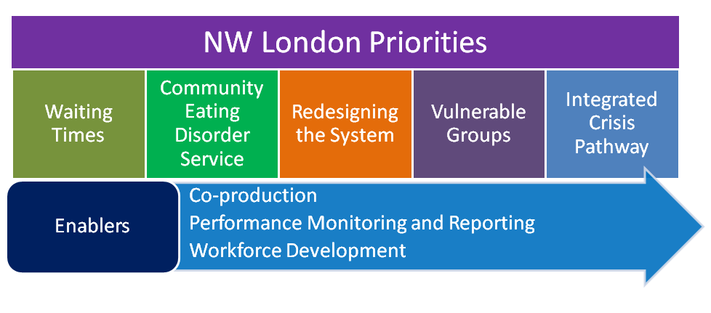
Financing our Transformation Plans
Funding has been provided to CCGs by NHS England since 2016 to improve pathways and to support transformation of services to positively impact on children and young people’s mental health. Majority of this funding have been invested in two Mental Health Trusts operating across NW London and the remainder of the investment commissioned local voluntary sector services for children and young people. In addition, we have secured small non-recurrent funds to invest workforce development across NWL. The attached local annexes set out funding allocation across priority areas in each year and describes how

Sustainability
The refreshed plan looks to strengthen the service developments already implemented and ensure prospective proposals will deliver fully aligned and integrated pathways and interventions. Our “whole-system” approach will focus on making sustainable changes within whole care pathways to deliver more cost effective care. We will review outcomes and value-for-money and make investment decisions based on meeting needs. This will guarantee that current and future needs of our children and young people are met and services are financially viable in the long term.

Our sustainability plan will be built upon:
- working together with commissioners and providers to review effectiveness and value-for-money of services and outcomes delivered and agree areas to shift resources from old systems to fund redesigned pathways,
- co-ordinating workforce planning across a larger footprint,
- creating capacity through up-skilling in universal and early intervention services to support children and young people in their communities,
- identifying opportunities presented in the development of integrated placed-based care services to be part of community and general practice provision, reducing costs, delivering better outcomes,
- identifying lower cost interventions such as the involvement of parents, peer support, digital based access to information and support,
- implementing our new model of care and shifting/re-distributing resources by redesigning our pathways to ensure sustainability of services.

5.1 Priority One: Access and Waiting Times

5.1.1 Our Ambition
Our aim is to provide timely access to NHS funded mental health services for children and young people, and to ensure that services are able to offer the full range of NICE recommended treatment options.

5.1.2 Our Performance and Progress
Increasing Access
The NHSE Five Year Forward View target requires that at least 35% of children with a diagnosable mental health conditions are seen for treatment by 2020, or increase in the numbers seen by at least 2% per year.

In 2017/18 six of the eight NW London boroughs have exceeded their targets in providing access to services. The three inner NW London boroughs have seen significant increase in their access rates due to unfortunate events unfolded during 2017 (Westminster Bridge attack and Grenfell Tower fire) to support children and young people affected by these events.

The two NW London boroughs, Ealing and Hillingdon, who have not reached targets developed recovery plans to address issues and the current data (quarter 1) in 2018/19 taken from the Mental Health Services Dataset shows that there is an improvement in both boroughs’ position.

The table below provides overview for each borough.

Progress Towards Targets |  | 2016/17 |  | 2017/18 |  | Target  2018/19 | Target  2019/20
 |  | Target | Actual | Target | Actual | Target  2018/19 | Target  2019/20
Borough | Estimated prevalence | 28% | 31% | 30% | 31.3% | 32% | 34%
Brent | 4572 | 1280 | 1158 | 1372 | 1449 | 1463 | 1554
Ealing | 4692 | 1314 | 1197 | 1408 | 1046 | 1501 | 1595
H&F | 1828 | 512 | 867 | 548 | 850 | 585 | 622
Harrow | 3171 | 888 | 940 | 951 | 1069 | 1015 | 1078
Hillingdon | 4051 | 1134 | 1421 | 1215 | 575 | 1296 | 1377
Hounslow | 3468 | 971 | 875 | 1040 | 1516 | 1110 | 1179
K&C | 1440 | 403 | 675 | 432 | 1189 | 461 | 489
Westminster | 2417 | 677 | 818 | 725 | 766 | 773 | 822

The above data represents both the specialist CAMHS providers and the voluntary sector providers. The capture of data has been a particular issue however, working collaboratively with all our providers, particularly with voluntary sector, to ensure they are able to flow the required datasets into the Mental Health Services Dataset.

Referrals
The following table represents all referral activity:

 | Central London | West London | H’don | Brent | Harrow |  | H&F | Ealing |  | H’slow
Referrals made
2016/17 | 587 | 1096 | 1289 | 1657 |  | 1079 | 1035 |  | 2093 |  | 1596
2017/18 | 702 | 1366 | 1302 | 1485 |  | 1104 | 1403 |  | 2350 |  | 1683
Referrals accepted
2016/17 | 416 | 792 | 828 | 766 | 627 |  | 922 |  | 1638 |  | 1108
2017/18 | 630 | 1112 | 982 | 1128 | 668 |  | 1148 |  | 1876 |  | 1220
% Referral acceptance rate
2016/17 | 71% | 72% | 64% | 46% | 58% |  | 89% |  | 78% |  | 69%
2017/18 | 90% | 79% | 70% | 71% | 59% |  | 82% |  | 80% |  | 72%

Whilst there is an overall 8% increase in the number of referrals made in NW London footprint level, the picture across the boroughs is varied with West London and Hammersmith and Fulham receiving a significantly greater number of referrals (20% increase, 26% increase respectively) than the other CCGs. The percentage of overall referrals accepted by CAMHS services across NW London has significantly improved with the exception of Hammersmith and Fulham where there has been a decrease of 7% in referral acceptance rates.

Waiting Times
The data below shows waiting times for referral to assessment for each borough. The increasing focus and additional investment to address waiting times rates resulted in significant progress in improving performance for ‘under 4 weeks and 5-11 weeks’ for all boroughs. However, the borough of Hammersmith and Fulham performance has declined, with more children and young people needing to wait between 5-11 weeks for their assessment.

This improvement however, has had a negative impact on the performance of most boroughs as there is increase in more children and young people needing to wait longer than 11 weeks for their assessment. A hypothesis is that resources have been focused on improving ‘referral to assessment’ waiting times which has had an impact on ‘assessment to treatment’. Further investigation needs to take place to determine the causes and balance resources to be able achieve reduction in both areas.
Waiting Times
 | Central London | West London | H’don | Brent | Harrow | H&F | Ealing | H’slow | Total NWL
Referral to Assessment Time
Under 4 weeks
2016/17 | 35 | 42 | 37 | 37 | 24 | 56 | 98 | 108 | 437
2017/18 | 17 | 10 | 11 | 12 | 10 | 11 | 31 | 21 | 123
5 - 11 weeks
2016/17 | 13 | 19 | 24 | 31 | 23 | 17 | 66 | 90 | 283
2017/18 | 6 | 15 | 14 | 14 | 18 | 26 | 10 | 20 | 123
over 11 weeks
2016/17 | 1 | 5 | 44 | 12 | 7 | 1 | 10 | 7 | 87
2017/18 | 2 | 4 | 45 | 10 | 6 | 9 | 14 | 10 | 100
Assessment to Treatment
Under 4 Weeks
2016/17 | 19 | 36 | 39 | 49 | 25 | 30 | 20 | 35 | 253
2017/18 | 6 | 14 | 25 | 26 | 16 | 31 | 40 | 19 | 177
5 to 11 weeks
2016/17 | 2 | 4 | 9 | 4 | 8 | 6 | 4 | 4 | 41
2017/18 | 1 | 1 | 7 | 3 | 8 | 6 | 3 | 8 | 37
over 11 weeks
2016/17 | 3 | 1 | 6 | 0 | 2 | 0 | 1 | 0 | 13
2017/18 | 1 | 1 | 3 | 0 | 2 | 6 | 3 | 4 | 20

Assessment to treatment ‘Under 4 weeks’ performance also has improved in majority of our boroughs, with the exception of Ealing. The ‘5-11 and over 11 weeks’ performances in Hammersmith and Fulham, Ealing and Hounslow have declined compared to 2016/17 performance.

Waiting Times: Specialist and Urgent Care
Number of CYP on Specialist CAMHS waiting list
 | Central London | West London | H’don | Brent | Harrow | H&F | Ealing | H’slow | Total NWL
2015/16 | 159 | 153 | 200 | 472 | 120 | 44 | 39 | 115 | 1302
2016/17 | 78 | 208 | 154 | 122 | 53 | 31 | 107 | 170 | 923
2017/18 | 34 | 58 | 64 | 64 | 34 | 81 | 84 | 226 | 645

Although the total numbers of referrals has increased across the sector by 8%, this increase has not led to a significant increase in waiting times across the boroughs, with the total number of children on specialist CAMHS waiting lists continuing to decline. Reductions in number of children on the waiting list can be seen in all boroughs with a significant improvement in West London CCG and Hillingdon; there has been an increase in the number of children on the waiting list in Hounslow and Hammersmith and Fulham CCGs – Hounslow have received a 26% increase which accounts for this increase in waiting time –however, there is a need to investigate the reason for Hounslow performance as there has been a small increase in the number of referrals (5%).

5.1.3 Next Steps
There remains an on-going commitment to improving timely access to NHS funded mental health services, and to ensuring there are a range of evidence based interventions for children and young people. The next phase of our priorities will be: to

- Review access and waiting time performance, use of resources and working in conjunction with providers establish the reasons for performance decline in areas to develop plans to address issues, including considering stretch targets.
- Review the findings of early intervention psychosis and autism pathways reviews to increase access for vulnerable children and young people.
- Build on our experiences of Grenfell which required quick assessment of patients, to ensure there is an effective and efficient referral screening and assessment, which is supported and integrated into the multi-disciplinary teams and share this across other areas to improve performance.
- Increase capability of the school workforce to provide help and support that will enable children and young people to help themselves with assistance from parents and peers. Consider the role of CYPIAPT in doing this.
- Align with ‘trailblazer pilot’ initiatives to clear backlog of children and young people waiting for treatment to ensure no waiting lists for accessing services, creating capacity to transform existing service models to be treated in four weeks. The aim of the new model would be to ensure targets are met across all providers and the whole system, as well as ensuring a sustainable and robust system to achieve minimum 35% access rate in 2020/21.
- Review plans and commitment to develop single point of access across NWL to provide timely access to the right help, at the right time and place.
- Address data collection issue and work collaboratively with all providers to successfully feed access and waiting time’s data into Mental Health Services Datasets to ensure completeness of data.
- In alignment with the crisis pathway development, consider an integrated single point of access for screening and risks assessment of referrals as well as triage assessments prior to signposting the referral to the right level of help.
- Continue to promote NHS Go App across NWL to support children, young people and families accessing information about self-care.

5.2 Priority Two: Community Eating Disorders (ED) Service

5.2.1 Our Ambition
We want to provide rapid access to wide ranging evidence based care and treatment to children and young people with a range of eating disorders and meet all eating disorder access and waiting times standards.

5.2.2 Our Progress and Performance
CAMHS Community Eating Disorder Services were launched on 1st April 2016, following a year-long pilot service, and was underpinned by the National specification for Eating Disorder Services and are compliant with the NICE Guidance (CG9). The services are integrated into CAMHS in both Trusts and are accessible Monday to Friday 9am to 5pm with additional support provided by the out of hours’ teams based in a number of EDs across NW London, and both Trusts. There is a wide ranging support available for children and young people and their families, including:

- a rapid single point of low-threshold access,
- advice, information and sign-posting to people with eating problems who do not wish to access treatment services (or who are not eligible for treatment);
- specialist consultancy to GPs whether or not the service is able to offer treatment;
- seamless onward referral to treatment services for people whose needs cannot be met within a community-based service (e.g. those at higher risk or requiring multi-disciplinary treatment and care);
- family interventions as a core component of evidence based treatment required for eating disorders in children and young people;
- cognitive behavioural therapy (CBT) and enhanced CBT (CBT-E) for the treatment of anorexia nervosa, bulimia nervosa and related adolescent presentations.
Both providers are registered with the Quality Network for Community Eating Disorder Services to improve their services, and have participated in self-assessment (below table) and peer reviews.

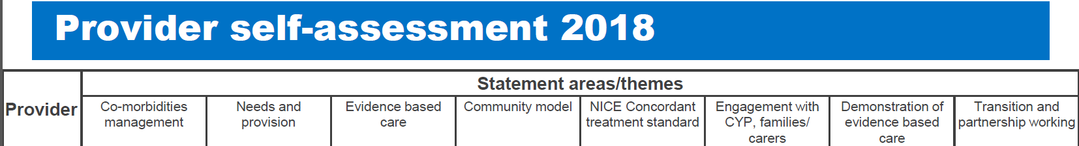
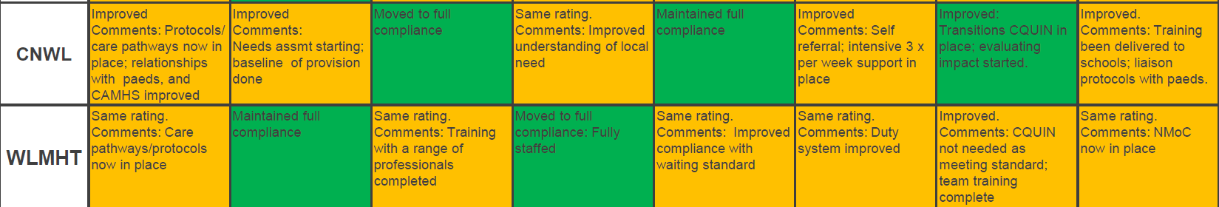

Access and Waiting Times
In 2017/18 there were 252 routine (65% increase) and 70 urgent (57% increase) referrals. Waiting times for routine and urgent referrals are monitored by NHSE with targets of 95% of routine appointments to be seen within 4 weeks and 100% of urgent referrals seen within one week. With minimal exceptions both CNWL and WLMHT met this trajectory. All breaches were attributed to families rearranging appointments, missed appointments, referral to alternative services and non-attendance rather than the ability to offer slots within the designated timescale rather than the ability to offer slots within the designated timescale.

Routine breaches are monitored at the monthly meetings between commissioners and providers in each borough with action plans implemented where performance does not meet specified targets.

Referrals
The vast majority of referrals continue to be from GP’s, followed by other CAMHS professionals, education professionals and social workers, with some young people self-referring to services.
Referrals to Eating Disorder service by CCG
 | Central London | West London | H’don | Brent | Harrow | H&F | Ealing | H’slow | TOTAL NWL
Number of routine referrals (4 week)
2016/17 | 17 | 14 | 22 | 17 | 19 | 18 | 35 | 22 | 164
2017/18 | 28 | 28 | 50 | 38 | 38 | 23 | 48 | 37 | 252
Number of urgent referrals (1 week)
2016/17 | 6 | 6 | 6 | 6 | 5 | 1 | 6 | 4 | 40
2017/18 | 4 | 20 | 16 | 14 | 10 | 2 | 2 | 2 | 70

There has been an increase in number of referrals to the service and an increase in the number of referrals not accepted by the service. Around 70% of those referred to CNWL services were accepted for treatment (71% routine, 21% urgent and 6% emergency), and around 92% of those referred to WLMHT were accepted for treatment (95% routine and 5% urgent).

Waiting Times
Compliance to National Waiting Times (%)
 | Central London | West London | H’don | Brent | Harrow |  | H&F |  | Ealing |  | H’slow
% Compliance to routine (4 week) waiting times
2016/17 | 88% | 79% | 77% | 88% | 79% | 88% |  | 89% |  | 59%
2017/18 | 86% | 100% | 71% | 58% | 78% | 96% |  | 92% |  | 90%
% Compliance to urgent (1 week) waiting times
2016/17 | 100% | 100% | 80% | 67% | 80% | 100% |  | 83% |  | 25%
2017/18 | 80% | 92% | 78% | 88% | 67% | 100% |  | 100% |  | 100%

All the urgent referrals of Ealing, Hammersmith and Fulham and Hounslow were seen within 1 week of being referred (overall target 100%), and there were 9 breeches during the year for routine referrals (overall target 92% vs national target of 95%).
The performance in Central London, West London, Hillingdon and Harrow however have declined. The numbers of referral in those boroughs are small and families opt for later appointments which take them outside the four weeks waiting times, affecting performance figures.

Outcomes Monitoring
As the services are now in their second year of operation, it has been possible to collect and compare baseline and end of treatment measures. Although the numbers are small, the outcomes look promising and show:

- Weight restoration to a healthy weight range in young people with anorexia nervosa,
- Significant reduction in eating disorder symptomology to below clinical thresholds
- Reduction in anxiety and depression symptoms reported by young people and parent,
- Improvement in overall general functioning.
Admissions
Tier 4 admissions
In 2017/18 a total of 15 children and young people were admitted into inpatient beds compared to previous years, and further 21 inpatient admissions have been avoided through providing support in the community preventing admission. Length of stay has also steadily reduced from 250 in 2014/15 to 128 days in 2017/18.

Paediatric admissions
Number of admissions to paediatric units has increased over the past three years to 20 in 2017/18. However, length of stay once admitted has fallen from 15 days in 2015/16 to 8 days in 2017/18. This is due to the teams being able to actively work with the Paediatric teams to support discharge as early as possible. Prior to having a Community ED Service, these patients would have most likely been referred directly onto an ED inpatient unit from the medical ward.

Service Evaluation
A second year evaluation of the service has been completed for both Trusts to provide an updated position for the 2017/18 in terms of access, activity/performance, outcomes, stakeholder satisfaction, safety and effectiveness given the current commissioned staffing model and service specification.

Improvements have been noticed in the way both Trusts operate both in terms of establishing an effective teams and ability to start collecting and comparing baseline and end of treatment measures. Family and friends tests and survey feedback from children, young people and their family provided a positive outlook in their experiences. There are good processes in place including discussing incidents/sharing experiences amongst staff in business meetings to have regular reflective practice sessions to consider team functioning and team dynamics that commonly arise from working in a MDT with Eating Disorders but interfere with cohesive collaborative practice.

A number of areas have been identified requiring further investment and redesign to create capacity and effectiveness of the service, such as developing an intensive outreach increasing nursing provision for most high risk cases.

5.2.3 Next Steps
Good progress has been made in 2017/18 particularly in managing needs in community and prevention of admissions. There is further commitment to improve the services and the next year’s priorities will be to:

- develop case for change for implementing recommendations of the service evaluations and improve waiting times performance and service effectiveness,
- improve data collection, particularly in relation to recording goals and routine outcome data,
- establish robust contract management/performance monitoring arrangements to regularly review compliance against national targets and standards, and mobilise improvement initiatives to address issues to offer high quality and accessible service.
- ensure providers, specifically WLMHT, are compliant to The Quality Network for Community Eating Disorder services for children and young people standards, and that recommendations emerging from self-assessment for Eating Disorder Services are progressed within service areas.

Feedback from some of our young people who have used the service (extract from the evaluation reports)

“We were so lucky to find the psychologist who has been an angel for us. She has treated our case with deep interest and great tact. Session after session she gained the confidence of my daughter and made her be conscious of the tricks of the illness, giving her the skills to fight it. She listened to her carefully and treated her with sweetness.”
“I feel that the
people who saw me listened to me”

“The team is exceptionally professional, caring and responsive. They always listen to our concerns and have given practical advice about handling several situations.”

North West London Eating Disorder Service

They understood and knew how to help which
made all the difference
I feel the people here know how to help with the problem I came for

5.3 Priority Three: Redesigning the System

5.3.1 The Ambition
The single greatest cause of concern amongst our young people and the professionals they interact with is about the barriers between different parts of the system. This tiered care system has at times restricted and limited the ability of a child or young person being seen by the most appropriate person or service; at the most appropriate time or suitable place.

We set our ambition as to move away from tiered services and eliminate boundaries and challenges of the old system to a new system in which children and young people are supported in their communities with services that are accessible and in accordance with the level of need.

5.3.2 Our Progress
We are working in collaboration with our partners to improve emotional health and wellbeing services across NW London where there is joint ownership of the issues and challenges we face and a collective approach to finding solutions. Working in partnership helps us to have a much bigger impact on the lives of children and families than we would ever be able to achieve alone.

The commissioners, clinicians and other stakeholders engaged and involved in our transformation programme have agreed to adopt THRIVE as a framework that supports our ambition to eliminate the boundaries between services and pathways and the culture shift needed across the system. The framework supports the move away from our historic negative association of poor patient experiences and provides a dynamic and innovative approach moving towards a goal focussed and collaborative approach that is not delineated within tiers.

THRIVE framework is a way of conceptualising need amongst a community of children, young people and their families. Need is measured under the five categories;

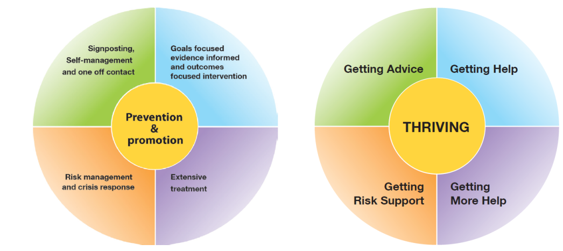
THRIVE conceptual Framework

- Thriving: Focus on community based initiatives concentrating on prevention and promotion of emotional wellbeing.
- Getting Advice: Building resilience to support communities (school and family) to prevent, support and intervene in mental health issues.
- Getting Help: Focuses on health based interventions with clear treatment goals and set criteria to assess whether those aims had been achieved.
- Getting More Help: Emphasis on intensive and extensive longer-term health based treatment.
- Risk Support: Often resource intensive and requiring considerable input, this group focuses on those children and young people for whom traditional health based care does not currently meet their needs.

Through adopting this framework, the outcomes we are seeking to achieve are:

- Reducing inequalities and improving health outcomes for children and young people (including equality/social cohesion, financial inclusion, attainment levels),
- Building a sustainable future (environment and sustainability),
- Improving the quality of care and experience, and
- Improving value and efficiency.

In order to deliver our ambition and above outcomes, numerous local initiatives have been implemented in each borough that provided early intervention, expand access and improve the quality of the support and treatment offered. However in order to have a systematic approach to transformation and to minimise variation across boroughs, a gap analyses have been undertaken to identify areas of focus for improvement, which are set out in below diagram.

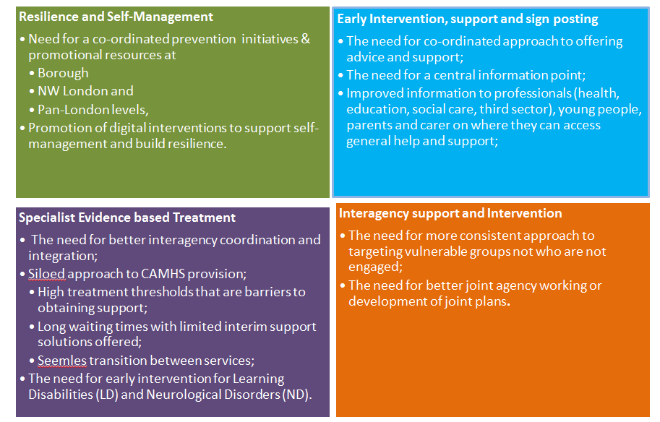
In addition, in line with the THRIVE framework, an overarching service model (diagram below) has been developed to be adopted in each borough to ensure a consistent offer across pathways and enable children to receive equitable and high quality support and care no matter where they live and access services.
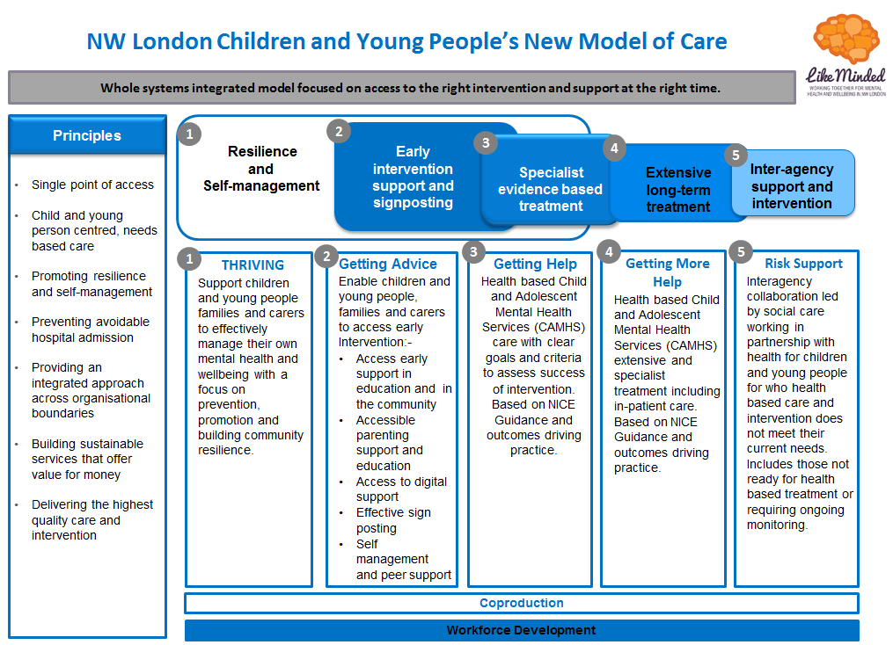

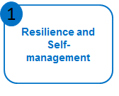
Step 1- Thriving- this element of the model is underpinned by an asset based approach to build on existing community resources to develop prevention and promotion initiatives. It supports better recognition of children’s and young people’s mental health issues and facilitates implementation of local strategies which promote emotional wellbeing and resilience for the population as a whole.

There is a coordinated approach with key individuals identified and adequately trained to take a lead in promoting children and young people’s mental health. Mental Health Needs Coordinators (MHeNCOs) are a key point of liaison and signposting to appropriate support and intervention. A centralised hub provides navigation to population based resources which promote emotional wellbeing.
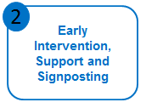
Step 2- Getting Advice- a focus on education, digital and community initiatives, getting advice seeks to enable children and young people, their families and carers to easily access and navigate early intervention and support. Linked and coordinated Multiple Access Points across NW London (MAPs) facilitate easy access to help and support. Joint services are delivered by health, education and the third sector who proactively work in partnership and signpost individuals to the existing array of support that exists in each borough as well as to newly developed resources. This includes a digital offer.

There is a coordinated multi agency approach in place (local authority, health, third sector) to identifying the best treatment option to be identified with intervention built around the needs wishes and preferences of each child or young person. Support will focus on building individual, family and carer resilience.

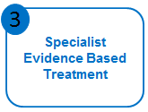
Step 3- Getting Help- led primarily by health with third sector input, getting help provides access to specialist evidence based treatment programmes. Clear pathways provide easy access to specialist services for referrers and service users alike. There are minimal waiting times well within the national specification of 18 weeks. Following assessment children and young people have access to a range of treatment modalities and a care plan built on shared decision making is designed to reflect the needs wishes and preferences of the child or young person. Goals are set which guide intervention and clear end points discussed at the start of treatment.
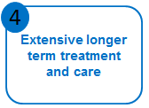
Step 5- Getting More Help
Led by health, this grouping sets out the requirement for children and young people who require extensive and intensive treatment. Clear pathways provide easily to navigate system which provides intensive community outreach, inpatient care and early community discharge initiatives. Where possible care will be community based with the implementation of highly skilled community teams who can provide extensive and intensive treatment programmes closer to home. Care is coordinated across the system to ensure appropriate treatment can be accessed no matter where the child or young person accesses help.

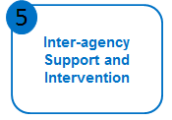
Step 6- Risk Support- inter-agency collaboration ensures access to appropriate support and intervention for complex children at risk or who pose a risk to others but for whom evidence based services are not applicable. This includes those who refuse or don’t attend treatment, have not responded to treatment or routinely go into crisis. Social care is the lead agency. A flexible system provides easily accessible and adaptable support when required thereby helping prevent crisis situations from arising.

The key to delivery of our vision is to significantly improve outcomes with a far greater emphasis (including investment) in prevention and earlier intervention across the system. However, as we moved forward with our implementation planning, the challenges of delivering ‘early intervention, support and signposting’ across eight boroughs, involving eight clinical commissioning groups, eight local authorities, two mental health trusts and 743 educational establishments has become clearer. Through engagement and conversation with key stakeholders, children and young people, education colleagues, local authorities and voluntary sector, it has been agreed that early intervention and prevention works best when delivered at borough level where local relationships can be built and community needs met.

Across NW London CCGs are working collaboratively with their local partners to increase their early intervention and prevention offer for children and young people’s mental health, and have utilised part of their LTP finances to enable a co-designed programme to be established with local voluntary sector and local authority providers of children and young people services. Further information can be found in each annex setting out how boroughs’ are implementing local programmes to meet their ambition.

The delivery of the remaining components of the THRIVE Framework and our new service model is progressed across NW London footprint collaboratively through the transformation programme to ensure variation in access, cost and quality issues are addressed. This collaborative approach has enabled the sharing and implementation of good/best practice, development of consistent pathways and quality standards, leading to improved quality and towards equitable services across NW London.
    - Our Next Steps
- Drive pathway redesign through the routine use of clinical outcomes measures, and explore the development of ‘outcomes framework’ and ‘outcomes based commissioning’ and work with CAMHS Outcome Research Consortium to improve the impact and value for money of care pathways,
- Adopt a phased approach to undertaking an audit/review to assess quality, performance and cost of services with whole scale change and the development of a culture which encourages sustainability in mind. We acknowledge that this approach holds a number of challenges and as such we will continue to align, drive and support changes at NW London level.
- Undertake a THRIVE self-assessment of the system to determine how ‘THRIVE-like’ we are and what actions are required to improve and embed the use of THRIVE principles in all areas of work.
- Review our collaborative plans and projects to look at delivering more efficient use of resources by commissioning and delivering some services at scale. The costs of specialist services are unlikely to be reduced, but efficiency will improved as a result of an implementation of THRIVE informed service delivery which will result in increased throughput.
- Improve our pathways as we work through CAMHS transformation and clarify different components of the whole system. This will include improving CAMHS element of Education and Care Plan. Our intention is also to ensure that this work aligns to existing best practice in Early Intervention Psychosis.
- Establish relationships, using emerging networks and transformation frameworks, for better integration of pathways with paediatric services to champion mental health needs of children and young people with physical health issues, and for culture change.
- Understand the developments of local integrated care systems, which may include children and young people’s emotional and wellbeing and mental health services, and ensure alignment between service models and commissioning and contract arrangements.

5.4 Priority Four: Vulnerable Groups

5.4.1 The Ambition
In the last two years, we have changed our focus on the scope of vulnerable groups as it was previously limited to cohorts of children and young people with learning disability (LD) and autistic spectrum disorder (ASD) and have been working across a variety of children and young people cohorts and partners. We have therefore widened the scope of this priority to include other vulnerable groups that are nationally recognised as being at risk of the effects of health inequalities are children and young people such as those;

- with learning disability (LD) and autistic spectrum disorder (ASD) and challenging behaviour,
- who are in transition process,
- with conduct disorders,
- who are involved in the youth justice system,
- who are looked after children.

NW London ambition is to ensure emotional and wellbeing support is available and easily accessible for our most vulnerable children and young people and that they are well supported to achieve their outcomes through specialist help and skilled workforce.

5.4.2 Our Progress
5.4.2.1 Children and Young People with Learning Disabilities and Neuro-developmental Disorders
In NW London the diagnosis and support services for children and young people are commissioned at borough level, and subsequently the level of investment and the provision varies across the eight boroughs. A recent mapping exercise has highlighted gaps in provision, including NICE recommendations for waiting times for assessments.

Activity Data
Below is an extract of the demand for LD services across NW London, and can be seen that both LD and ASD referrals have increased significantly in Central London and Hillingdon, whilst there has been either slight increase/decrease in other boroughs.
Learning Disability (LD) Referrals
 | CNWL |  |  |  |  | WLMHT |  |  | NWL
 | Central London | West London | H’don | Brent | Harrow | H&F | Ealing | H’slow | NWL
2014/15 | 11 | 13 | 18 | 49 | 37 | 6 | 73 | 43 | 250
2015/16 | 10 | 12 | 29 | 33 | 41 | 14 | 60 | 41 | 240
2016/17 | 10 | 42 | 39 | 48 | 64 | 7 | 115 | 53 | 378
2017/18 | 30 | 50 | 54 | 46 | 46 | 10 | 92 | 43 | 371

Learning Disability Contacts
 | CNWL |  |  |  |  | WLMHT
 | Central London | West London | H’don | Brent | Harrow | H&F | Ealing | H’slow | TOTAL NWL
2014/15 | 390 | 145 | 706 | 284 | 212 | 152 | 740 | 127 | 2756
2015/16 | 425 | 259 | 807 | 390 | 187 | 248 | 675 | 253 | 3244
2016/17 | 580 | 112 | 1369 | 908 | 773 | 194 | 1012 | 311 | 5259
2017/18 | 279 | 813 | 950 | 675 | 1388 | 718 | 1012 | 2179 | 8014
2018/19  (forecast based on M1-M6 actuals) | 507 | 654 | 810 | 582 | 1311 | 668 | 962 | 2124 | 7618

There has been significant increase in contacts for learning disability in all boroughs with the exception of Ealing. This is partly as a result of additional investment provided within CNWL boroughs, but also in relation to the children’s presentations.

Neurodevelopmental (ND) Referrals
 | CNWL |  |  |  |  | WLMHT |  |  | NWL
 | Central London | West London | H’don | Brent | Harrow | H&F | Ealing | H’slow | NWL
2014/15 | 19 | 32 | 39 | 67 | 79 | 26 | 313 | 365 | 940
2015/16 | 21 | 29 | 19 | 65 | 49 | 13 | 317 | 330 | 843
2016/17 | 31 | 60 | 55 | 107 | 93 | 32 | 429 | 421 | 1228
2017/18 | 91 | 55 | 153 | 173 | 120 | 33 | 353 | 393 | 1372
2018/19 (forecast based on M1-M6 actuals) | 94 | 57 | 157 | 178 | 123 | 33 | 437 | 365 | 1444
There has also been significant change in ND referrals specifically in Central London, Hillingdon and Brent, with Harrow seeing slightly lower rate of increase. There has been much work to raise awareness of services with GPs, schools and LAs, highlighting pathways to services, and Trusts have been working to improve their data quality for reporting purposes. Analysis will be undertaken to understand the causes of this significant change in referrals to ensure accurate picture leads to adequate provision. In comparison, the referrals in other boroughs have slightly decreased which will also need to be investigated as this is not in line with the population growth and prevalence.
ND Contacts
 | CNWL |  |  |  |  | WLMHT
 | Central London | West London | H’don | Brent | Harrow | H&F | Ealing | H’slow | TOTAL NWL
2014/15 | 403 | 323 | 269 | 578 | 862 | 186 | 1255 | 2200 | 6076
2015/16 | 516 | 341 | 289 | 666 | 733 | 262 | 1227 | 2318 | 6352
2016/17 | 524 | 241 | 555 | 774 | 678 | 366 | 1382 | 2797 | 7317
2017/18 | 387 | 266 | 745 | 580 | 844 | 718 | 1012 | 2179 | 6731
2018/19 (forecast based on M1-M6 actuals) | 423 | 519 | 912 | 708 | 897 | 668 | 962 | 2124 | 7213

Further analysis is needed to understand the referral for assessment and contacts delivered in order to determine the reasons for differences in year-on-year activity, both referrals and contacts.
Inpatient Data (LD and/or ASD)
 | Central London | West London | H’don | Brent | Harrow | H&F | Ealing | H’slow | NWL
Admissions | 2 | 2 | 1 | 2 | 4 | 0 | 7 | 4 | 22
Discharges | 2 | 1 | 2 | 0 | 5 | 0 | 1 | 1 | 12
No of Patients in March 2018 | 0 | 1 | 0 | 3 | 1 | 0 | 3 | 4 | 12

There was a net increase in the number of inpatients in 2017/18. There were 12 patients on 31 March as compared to 6 the previous year. Further analysis is needed to fully understand the factors leading to the recent spike in admissions. Initial findings suggest that the increase is partly due to an increase in the number of children and young people who receive an autism diagnosis whilst they are in hospital. These patients tend to be in mainstream schools and not in receipt of services from social care, and would not have met the criteria for inclusion on the dynamic risk/ admission avoidance register. This signals the need for early diagnosis and intervention. The increase in admissions could also be linked to the increase in the number of neurodevelopmental referrals to CNWL and WLMHT which potentially signifies an increase in the ASD population. The additional capacity of CAMHS Tier 4 provision is also considered to be a contributing factor to the increase in admissions; the rationale being that in some instances, by the time a bed became available, there was no longer the need for an admission as the crisis and risks had subsided.

Transforming Care Partnerships Programme (TCP)
With the increase demand and need, and the increase in admissions, we need to change the way we work across the system to ensure we can adequately support children and young people in the community. There are two established programmes in NW London; TCP and CAMHS Transformation programmes. Whilst each programme has considered the needs of children and young people with LD and/or ASD, and transformation activities, the closer alignment between the two became critical. A review of the work programmes took place to determine the optimum delivery and governance arrangements to ensure that the Lenehan review, ‘building the right support’ and the NHSE guidance ‘developing support and services for children and young people with a learning disability, autism or both’ could be implemented effectively. It has been agreed to set up a separate workstream comprising CAMHS and commissioning leads at NW London level, and Special Education and Disability (SEND) leads at local level, reporting both to TCP Board, and the CAMHS Transformation Board. This approach will improve the interface with the wider CAMHS programme of work, ensuring that the needs of children and young people with LD and/or ASD can be met within mainstream provision (e.g. crisis care, eating disorder services) via reasonable adjustments where appropriate and safe.

NHS England is overseeing implementation of the TCP and regular highlight reporting is taking place in relation to the agreed actions of the workstream. We have standardised and implemented the dynamic risk registers and multi-agency Care Education Treatment Reviews (CETR) across the footprint to minimise admission and length of stay. We need to work closely with local teams in the community to be proactive in developing and reviewing their dynamic risk registers and work with local commissioners to plan CETRs. There has been a spike in admissions in NWL in the last year which signals the need to strengthen links with Specialised Commissioning and children’s services to better understand the reasons for this increase, to review the use of dynamic risk registers and consider what the TCP can do to support areas to reduce admissions and length of stay. Partners are working closely together to ensure the commissioning of community services responds to individual needs of children and young people to enable their safe and appropriate discharge, with a robust package of care in the community. A recent deep dive completed by NHSE into the circumstances surrounding admissions of autistic patients has been helpful in identifying some of the challenges and gaps. The most recent feedback from NHS England rated the Partnership’s progress against the plan as amber and has highlighted the positive aspects in relation to our local TCP for children and young people and identified areas for improvement.

A service operating/delivery model has been developed for adults with LD and ASD, which will be adopted for children and young people- see proposed children’s model. This model, also aligns with the CAMHS service model/THRIVE framework.

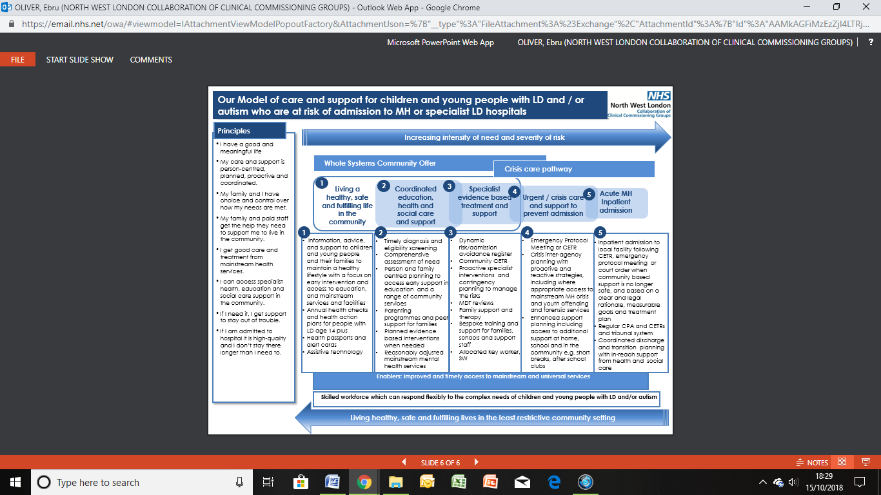
Steps 1 – 2 of the model rely on a whole systems community offer which includes improved and timely access to mainstream and universal services as well as timely diagnosis, early intervention and specialist evidence based treatment and support provided by the local teams when needed. The starting point will always be for mainstream services to support children and young people with LD and/or ASD, making reasonable adjustments where necessary and with access to specialist multi-disciplinary support from health and social care teams as appropriate to ensure this cohort experience the same health outcomes in line with the general population. For the Transforming Care cohort, access to annual health checks, health action plans, health passports and / or alert cards are particularly important. LD and autism awareness training should be available for professionals working in universal services

Also, key to the success of the model is person/family centred support planning with access to skilled and experienced staff in schools and community settings e.g. youth clubs, after school clubs. Technology based support which contributes to increased independence will be considered as an addition or alternative to traditional support models.

The model recognises the importance of good support to families, ensuring they have access to support well before they reach crisis point. Parenting programmes, advocacy, information, advice, training and support will be available for families to support them in their parenting role, including access to peer support.

Step 3 of the model describes the additional specialist clinical and social care support that should be made available to children and young people with complex sensory, emotional, behavioural and/or mental health needs who are presenting some level of risk to themselves or others which can’t be safely managed by universal services or within their current care package. Interventions will be dependent on individual need but could include functional behaviour assessments, positive behaviour support plans, communications passports, medication reviews, restriction reduction plans, offender programmes and sensory integration plans, and subject to regular reviews coordinated by an allocated care coordinator or social worker. Clinicians will provide specialist training and consultancy to community and education providers and the families to support them to create capable environments at home and in other community settings. Family therapy will be made available, especially during any transition phases. Access to reasonably adjusted offender programmes and interagency treatment and support will be made available to CYP with offending behaviour.

Dynamic risk/admission avoidance registers will be used systematically to identify CYP who may be at risk of admission, exclusion from school or placement breakdown with regular MDT discussions with local commissioners to formulate contingency plans and specialist early interventions. There will be a link between the children and adult registers, where young people are approaching transition. Where it is felt that the risks are likely to continue to escalate, a Community Care Education and Treatment Review (CETR) should be organised.

Steps 4 – 5 illustrate the interagency interventions needed to support CYP in crisis and avoid exclusion from school, unnecessary admissions to inpatient units or 52-week education placements. This includes the need for crisis and contingency planning via emergency protocol meetings where there is insufficient time to organise a community CETR. Crisis and contingency plans and health passports will be shared with relevant clinicians working in mainstream MH crisis services including A&E. A social worker or key worker will be allocated to lead on support planning which will consider the impact on the family system and make provision for short breaks and additional support.

Crisis and relapse prevention treatment and therapeutic offending programmes led by a specialist forensic team will be available for children and young people with serious offending behaviour who are at risk of admission to hospital or contact with the criminal justice system.

If children and young people are admitted to hospital, it will be following a CETR, emergency protocol meeting or court order and be in a service close to home. Where safe and appropriate, patients with autism or mild LD and a mental health diagnosis should be able to access mainstream CAMHS beds, with in-reach advice and support from the specialist team if needed. Clinicians and social workers within the relevant community teams will work with commissioners to agree the outcomes of the admission which will be made explicit in the contract with the inpatient provider as well as the patient’s care and treatment plan.

Following an admission, especially those without a community CETR, the relevant team(s) in consultation with the commissioner should undertake a root cause analysis to identify any unmet needs, share lessons learned and reflect on what, if anything could have been done differently to avoid the admission. The findings will then be used to inform changes to local policies and practice.

Local Initiatives/Pilots
Much of the Transforming Care programme is driven locally due to the essential part played by the local authorities and education. Some examples of local pilots and initiatives which aim to support early identification and /or targeted interventions for children and young people and their families in the community are highlighted below:
- Ealing Council have used funding from the Department of Education to develop their Building My Future project to provide youth work, advocacy, mentoring and family therapy, to young people with learning disabilities and/or autism age 11 plus on the edge of care within the mainstream school structure. The project sets out to ensure that young people and their families receive wrap around support at an earlier stage to reduce the risk of crisis, family breakdown, exclusion and admission, and to support successful transition to adulthood. A Risk of Escalation Tool which will be developed to identify those who meet the criteria for the programme has the potential to be shared nationally as a best practice model.
- A Hillingdon parent has established a parent to parent initiative and set up a group offering peer support and positive emotional well-being and emotional regulation for parents of children with ASD/ADHD. Feedback from group members is positive and the CCG will be working with the group to evaluate the outcomes and benefits of the group in 2018/19.
- Hounslow have developed an intensive community support service for children & young people with LD, autism and challenging behaviour who are at risk of admission, exclusion or placement breakdown. The model is a collaborative initiative between clinical psychology, social care and short breaks services. Families are provided with an individually tailored package of short-term intensive psychological interventions and additional short breaks, using a Positive Behaviour Support (PBS) and Systemic approach.
- We are exploring the benefits of technology based support and has funded a pilot in Ealing to offer the ‘Brain in Hand App’ to autistic young people and adults and they will share the learning across the eight boroughs to support the funding of the app. Brain in Hand is a phone app which offers an alternative to traditional support models and face to face contact by providing a personalised solution to increase independence by empowering the person to manage anxiety and stressful situations and avoid crisis.
- We are using funding from NHSE to create family assertive outreach workers to focus support to vulnerable families of autistic children and young people living in Ealing and Hounslow. This initiative aims to develop the families’ capacity and infrastructure and support their relationship and engagement with helping services. This approach will be reviewed and findings will be used to support wider roll-out across NW London.

Collaborative Commissioning and Tier 4 Beds
Specialised Commissioning are working with CNWL and Elysium to develop London based specialist Tier 4 inpatient CAMHS to deliver better access to care for children and young people with LD and/or ASD closer to home.

- 5-bedded specialist Tier 4 inpatient CAMHS LD unit to be provided by CNWL at the Kingswood site in Brent, from early 2019. This will offer a mixed gender service for young people aged 14 – 18 with LD and challenging needs and /or mental health condition,
- 9-bedded specialist Tier 4 inpatient CAMHS neuro-developmental disorders unit provided by Elysium. The service is based in Potters Bar and will be available to young people aged between 13 – 18 who have an already established diagnosis of ASD, with or without LD.
The development of London based services provides an excellent opportunity for partnership working between the TCP, NHSE and the providers to integrate provision within the wider local care pathways and support early engagement of families, local clinicians, social workers, and community providers in discharge planning. As with the national New Models of Care programme, this initiative is likely to lead to a reduction in spend on inpatient provision. We are keen to work with NHSE to explore the potential of re-investing any savings into developing the community infrastructure and services which offer children and young people an alternative to a hospital admission.

Next Steps
- finalise the dynamic risk register of those children and young people who may be at risk of an inpatient admission and embed the CTR/CETR processes locally for pre-admission and discharge meetings involving all partners and users/carers to design and commission individualised packages of care and support,
- undertake a deep dive into Community CETRs and children and young people admissions to identify good practice, gaps in local services and processes and what can be done differently to avoid unnecessary admissions in the future,
- building on the processes already in place for adult patients, consider introducing a systematic approach for escalating delayed discharges and CETRs, to unblock barriers,
- deliver clear joined up approach: linking services so care pathways are easier to navigate for all children and young people, including those who are most vulnerable,
- develop collaborative commissioning plans with NHS England Specialist Commissioning for children and young people with complex needs and develop a robust crisis and community based response to crisis offer,
- identify external funding opportunities to establish alternatives to admission,
- review and share findings of local initiatives such as positive behaviour support, family assertive outreach workers and the use of digital technology for rolling out across NW London footprint,
- improve access for families to pre and post diagnostic support and neuro-developmental assessments and support, including consideration of footprint wide service specification to reduce variation of care across boroughs,
- Investigate adoption of Health Passports to support mainstream primary and secondary healthcare services to improve access to care and treatment for young autistic patients,
- review neuro-developmental pathways in order to reduce waiting times and embed the transforming care principles to reduce the use of residential placements,
- embed sustainable PBS training across NW London,
- complete ‘borough level self-assessment’ against TCP model and principles, and to identify gaps to form the basis of the local and NW London level action plan.
5.4.2.2 Transitions
The issues of transitions from children to adult mental health services has been raised numerous times as to a challenging time for both children, young people and their families. In recognition of this, NW London is committed to improving experiences of everyone involved in the process to ensure smooth transition to adult services as well as improving the support and journey of those who are leaving CAMHS at 18.

As part of this commitment, NW London commissioned Young Minds to develop a modular training model for improvement. In first phase of this project, Young Minds has involved a large number of young people, parents and professionals, CAMHS to map pathways, identify gaps and complete an audit around development needs.

Whilst the need of a specific service provision/team has come up a number of times, challenges of a ‘transition service’ were also outlined by some families and professionals about creating another age related divide between services. There were however number of key challenges identified in the relationship between child and adult services which were deemed more critical in improving the experiences of young people, families and professionals, including:

- Lack of understanding about how the other service works and a lack of shared understanding about the needs of the young adults aged 18-25,
- Poor communication between services- desire to have dedicated leads for transitions in CAMHS and AMHS accountable for ensuring the transition protocols is implemented in both services, regular meetings between service areas, placements in service areas and buddying up,
- Lack of suitable environment for young people moving into adult units,
- Lack of suitable options for young people who still need support at 18 but cannot access ongoing support due to thresholds,
- More accessible resources for parents and carers about what happens when young people approach 16/18 and about their rights,
- More information for parents whose child is moving to adult services around how it is different and what to expect,

The insight phase of the project has resulted in commissioners and providers gaining a rich picture of current challenges and strengths around transitions and generated new ideas about how transitions could be improved. Based on the findings of this phase we have agreed to augment the insight phase to have further engagement with hard to reach groups, larger cohort of education providers and general practitioners to get a more holistic picture of the current system. We will focus on improving transitions for young people moving from children’s mental health services to adult mental health services. Young Minds will continue to work in phase three of the project to facilitate culture change by organising ‘communities of practice’, development of principles and resources to be adopted across the system, build relations across children’s and adult’s services and the development of processes and protocols will be informed by the learning gained from the action learning sets and the local development initiatives.

The progress continues with the transitions out of CAMHS CQUIN. During Q4 of 2017/18, a case note audit took place for those individuals transitioning to adult mental health services during Q4. The case note audit evidenced 74% of those audited were transferred back to primary care and 26% met the thresholds for adult mental health services. Additionally, both CAMHS and adult mental health services conducted surveys to understand the experience of those transitioning from CAMHS.

Next steps
- complete second insight phase to finalise ‘as-is mapping’ and develop key deliverables identified in the final report e.g. gap analysis for service provision, training programmes, action learning sets, principles and resources including enhanced NHS passport for commissioners to approve,
- improve joint working across service boundaries- adult services, CAMHS, education providers, voluntary sector providers.
- continue monitoring CQUIN achievements to improve performance and determine what extra measures are required, including review of the current survey methodology and rolling out good practice process currently in place in some of the boroughs.

5.4.2.3 Complex Needs- Early Intervention Psychosis
It is important to provide support to children and young people with a first episode of psychosis as early as possible. Early intervention and treatment can improve long-term outcomes. NW London performance of % people experiencing a first episode of psychosis treated with a NICE package within two weeks is significantly above the set target.

Next Steps
- develop robust monitoring framework to monitor the performance of services, including understanding of skills gaps, training requirements and workforce vacancies,
- review the effectiveness of the service model, including the NICE compliant interventions, to identify gaps and service improvements whilst reducing demand on core CAMHS services,
- develop robust local arrangements between CAMHS and EIP services so that specialist expertise in working with children and young people with psychosis is available.
5.4.2.4 Young People in the Criminal Justice System
Future in Mind 2015 outlined the need to transform ‘care for the most vulnerable’ which includes mental health of children who come to the attention of criminal justice system.

NW London has prioritised to support children and young people in or at risk of entering the justice system and utilised the additional funding provided to provide timely assessment and diversion through mental health liaison and diversion support, and introduced targeted interventions through community approaches which promoted social connectivity and underpinned community resilience. The current Liaison and Diversion support is currently commissioned and funded through NHS England and Youth Justice Board and discussions will need to take place to agree arrangements for funding after March 2020. Further information on local progress can be found in local annexes as each borough has progressed their individual plans given the multi-disciplinary and multi-agency approaches within the pathways.

5.4.2.5 Looked After Children
LAC frequently have multiple and complex needs and to address these needs a multi-agency approach with education, health and local authorities working in partnership is essential. There are plans in place in each NW London borough, working conjunction with local authority, education and voluntary sector specifically to meet the needs of looked after children. Further details can be seen in local annexes.
5.4.2.6 Conduct Disorder
A pilot, ‘Expanding Parenting Provision’ was set up in Ealing to test an integrated approach between health and education to prevent and/or intervene in the development of conduct disorder through early identification, training and positive parenting support delivered within schools. The pilot was delivered in two phases; the first phase taking place between Sept17-Dec17 in which participant school, staff and supervisors were identified and trained to deliver the pilot, and the second phase taking place between Jan18-July18 in which parents were trained. The pilot has so far delivered 12 of 14 parenting courses in seven Ealing schools between, with the remaining two course to be delivered by end 2018. 117 parents participated in the courses, with 80 attending the tenth and final session (conservatively, retention rate varied between 33% and 92% per course).
Evaluation has demonstrated a significant improvement in parent-reported child behaviour (50% improvement in 'Concerns about my child' score; p<0.00001), and a significant improvement in parental well-being (3 point improvement, Short-Warwick-Edinburgh mental wellbeing scale 'SWEMWBS'; p<0.00001), for parents completing the course. Evidence suggests improvements in classroom behaviour, although this was for a small sample of children (n=37) using a non-validated measure. Parents also reported improved community connectedness as a result of these group courses.

Uptake from schools was favourable, and the programme has provided opportunities for professional development for staff and future recruited parents. There were family identification/recruitment challenges for some schools, and targeting of higher-need families was universally challenging. Only one third of participants' children had behavioural issues identified, meaning the pilot was operating more as a universal prevention programme.

A challenge to resourcing of this pilot was the operative demands of multidisciplinary and integrated working - for example between multiple clinicians and multiple schools - and in order to scale up it will be necessary to find ways of streamlining these processes. Plans are underway in Ealing to sustain the pilot through training parents from these courses to deliver further courses in the community as a primary prevention model in their local offer- especially as an offer to parents who are on waiting lists for CAMHS. The full evaluation will be completed later in the year and will be used to inform plans for wider implementation of the model across NW London.

5.5 Priority Five: Integrated Crisis and Urgent Care Pathway

5.5.1 The Ambition
The Five Year Forward View requires NHS to deliver effective 24/7 crisis resolution and home treatment services to ensure community based mental health crisis response is available in all areas and are adequately resourced to offer intensive home treatment as an alternative to acute admission.

In NW London our aim is to develop an equivalent model for children and young people and we want to provide integrated 24/7 support and intervention for children and young people in mental health crisis providing timely access to care and support, reducing avoidable admission to hospital, preventing inappropriate admissions, and linked them to intensive community support services.

5.5.2 Progress
Integrated Crisis and Urgent Care Pathway
The early stage of the transformation programme has seen the piloting and commissioning of the ‘Out of Hours Crisis Services’ by two Trusts across all boroughs to provide support to children and young people with higher levels of mental health needs, bringing parity of esteem for those presenting with mental health issues in Emergency Departments (EDs) during out of hours. The assessment services have been available to all children and young people who present in crisis in EDs, Urgent Care Centres, in Section 136 suites and when an emergency admission is sought, and have been provided by qualified CAMHS nurses.

The evaluation of the Services was undertaken at the end of the pilot phase and although they had met the general aims, the following challenges were identified;

- Difficulty recruiting staff on this shift pattern leading to over reliance on agency staff;
- Challenges with capacity due to delivering services over a large geographical area leading to reliance on existing staff such as Psychiatric Liaison Services to review CYP within contacted timescales;
- Fragmented service provision with out of hours not linked to in hour’s crisis services;
- Health focussed with limited social care input;
- Capacity to support training of ED staff limited in some areas;
- Ability to fully support other colleagues i.e. police, paramedics limited due to capacity;
- Intensive community service focussed on reducing unnecessary admission not in place in all areas.
In order to address these challenges, additional funding was identified and allocated in April 2017 to pilot a two year fully integrated 24/7 crisis and urgent care and community based outreach teams ensuring children and young people experience the same high-quality care and consistent pathways no matter where they access care.

The integrated 24/7 service was launched to provide intensive crisis and community intervention to prevent unnecessary hospital admission, facilitate early and safe discharge, reduce prevention of admission, reduction in length of stay and a reduction of admission to acute paediatric beds across the NW London footprint. The teams are offering ED liaison assessments, seven day follow up’s, supported discharge and home treatment. This new service has also been an enabler for the New Models of Care project in facilitating discharges from out of area placements. Since its launch in January 2018, total of 1008 children and young people have accessed the service- 35% increase compared with the previous years. The vast majority of cases assessed were for self-harm, suicidal ideation and overdose incidents, and the promotion of the service across the system has been instrumental in identifying young people early to provide timely support. NW London acute hospitals have CAMHS liaison in place and robust links between CAMHS and adult liaison psychiatry are already established.
Assessments
Central London | West London | H’don | Brent | H’w | H&F | Ealing | H’slow | TOTAL NWL
82 | 66 | 200 | 153 | 135 | 110 | 137 | 112 | 1008

Reasons for urgent referrals:
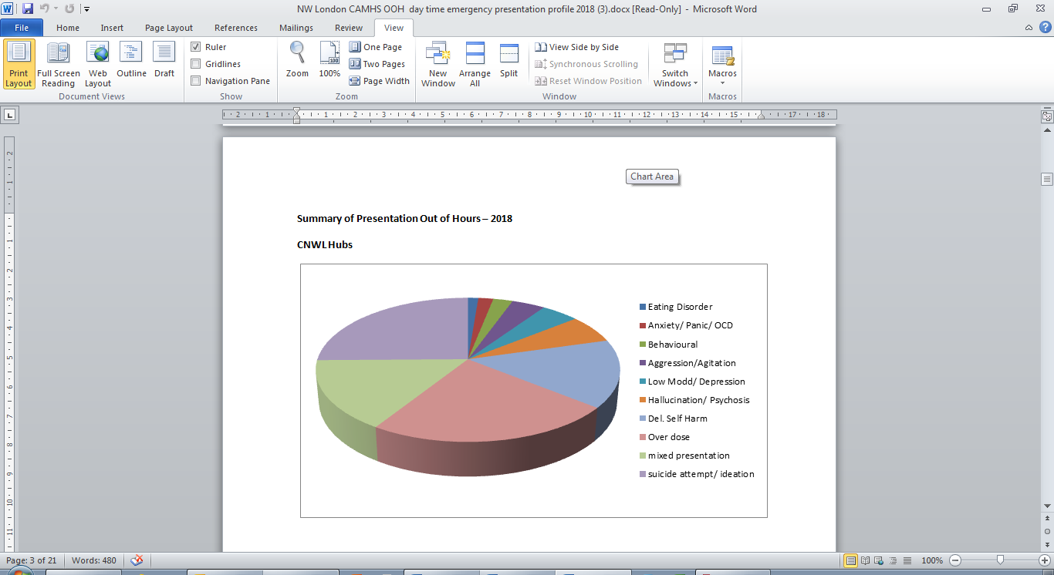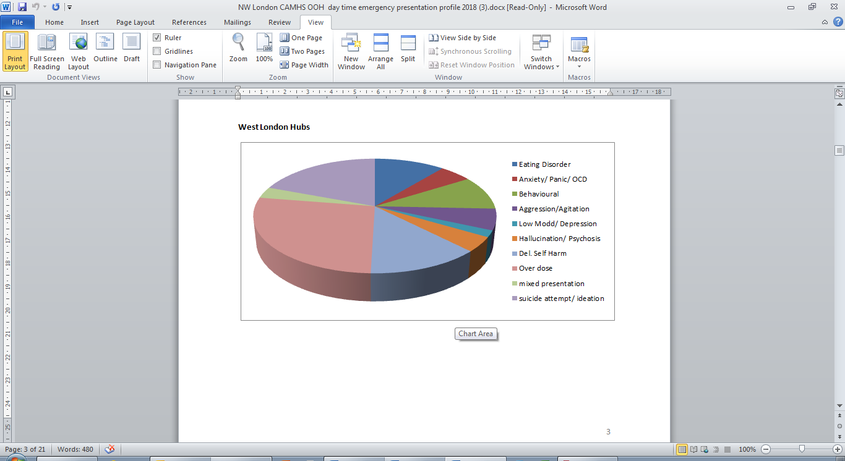

In order to further support the development the crisis pathway offer further funding of £192,000 has been secured from the national crisis funds to develop an enhanced training programme to enable the crisis teams to manage more complex patients in the community, including children and young people with learning disabilities and autism spectrum disorder. The funding has been used to train all urgent care staff in specific modalities for crisis, and delivered the following benefits:

- interventions from initial assessment in ED with safe discharge back in to the community to facilitate earlier discharge from Tier 4 beds and prevent Tier 4 admissions,
- on-going shadowing of other professionals across the health and social care system to foster good working relationships
- facilitating on-going reflective practice and supervision slots to ensure robust systems in place to promote best practice for patients and psychological safety/well-being of staff.

CAMHS Tier 4 Beds
During 2017/18 there was a decrease in the number of children and young people in Tier 4 beds which can in part be attributed to a sustained reduction in the number of new admissions to Tier 4 as well as increasing numbers of discharges. There were also significant improvements in numbers of occupied beds days, the average length of stay in beds and the numbers of children placed outside of their local area, resulting in less disruption to family life, education and young person’s social life and minimising adoption of risky behaviours from peers.
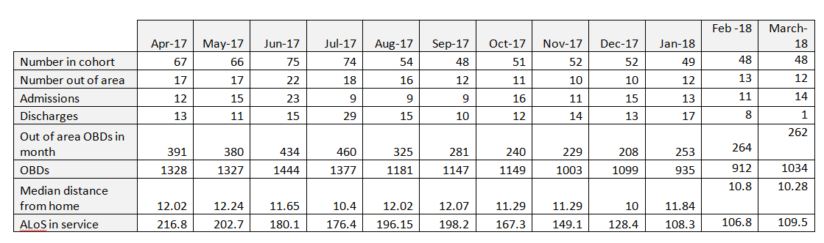

Collaborative Commissioning- New Models of Care
In October 2016, working in collaboration between WLMTH and CNWL, NHS England Specialised Commissioning has launched New Models of Care pilot project to address many concerns related to the provision of CAMHS Tier 4 beds including capacity issues, problems accessing required beds and children and young people travelling long distances to access inpatient care. The purpose of the pilot was to trial new ways of managing the pathway to Tier 4 inpatient admissions to:

- prevent avoidable psychiatric hospital admissions
- admit young people closer to home
- reduce length of stay for young people admitted to Tier 4 beds
- eliminate clinically inappropriate out of area placements
- reinvest savings in improved community services for young people
Following a twelve month shadow period, the pilot project has been mobilised under a two year contract in April 2017 and the clinical commissioning groups have been an integral part of the pilot to support providers by increasing the investment in crisis pathway to enable the anticipated savings to be realised through improved bed usage. The key element and the central to the success of the model is the implementation of Clinical Review and Forward Thinking meetings (CRAFT) which take place on admission and plan what needs to be addressed for the young person to be successfully discharged. In order to ensure the greatest impact, the focus has initially been on supporting adolescents requiring acute generic and eating disorder inpatient care.
The project has been success in the first year, yielding substantial savings to be invested it within pathways. Discussions are underway between Trusts and commissioners to identify priority investment areas.

Collaborative Commissioning: Lavender Walk Provision of Tier 4 Beds
Earlier in the year, CNWL has been given confirmation to build and develop a new inpatient unit in South Kensington for adolescents with mental health difficulties. This new development of twelve beds is critical as there was a concern about a shortage of dedicated adolescents beds in NW London hampering the effectiveness of community crisis pathways developed. Whilst the needs of children are managed in their communities and at home, there are times short hospital stay is needed and the new unit gives us the capacity and flexibility to improvement treatments for young people closer to home. Currently when a child is unable to access a specialist Tier 4 bed they may be admitted to paediatric beds. The opening of the new ward will help to ease this issue and also reduce waiting to specialist beds.

Through this development there will be a better ability to manage bed availability, reduce length of inpatient stay by keeping it local, more support for families reducing the disruption to a young people’s life. The new Unit will become operational in November 2018 and the clinical model of the unit consists of two components:

Clinical Model
The Clinical Model is aligned to the principles of the New Model of Care project. It moves away from the traditional model that aims for full clinical recovery in hospital, leading to long lengths of stay. Instead, the focus of admissions will be on initiation of treatment and community risk reduction interventions to support early discharge and ongoing treatment at home. Critical to the model is highly integrated inpatient, crisis, and CAMHS care pathways; and a flexible, needs-led approach to care planning and delivery.

The unit will provide a crisis and brief admission service for young people aged between 13 and 18 years with severe and/or complex mental health conditions associated with high medical or psychosocial risk. Length of stay will vary according to individual need, with the majority falling between 1–28 days. Discharge planning will commence on day of admission, using a partnership approach between inpatient services, community crisis teams, family and other community services such as schools.

Day Patient Model
This is an integrated community treatment programme with the capacity to offer intensive multidisciplinary treatment for young people who are in crisis or acutely unwell and may otherwise need to be admitted. The day patient model will function both as a ‘step-up’ from outpatient care and as a ‘step-down’ from inpatient care to support earlier discharge. The aim is to maintain young people in their own home, in the community, with the least disruption to their daily life whenever possible; and to minimise time in hospital when that cannot be avoided.
The service will be provided within a 12-bedded inpatient facility, co-located with day patient and outpatient CAMH services. The unit will facilitate and host a NW sector crisis pathway network to ensure optimal integration of inpatient, crisis, and CAMHS across the whole sector. This approach will allow CNWL and WLMHT to provide seamless care pathways, which will ensure young people get timely access to inpatient care when needed and the earliest possible discharge to continuity of care at home. This approach has been very effective within the CNWL Adult Eating Disorders Service, such that it is effectively the main provider of inpatient services for NWL.

Education
School provision and tailored educational support will be an integral part of both the inpatient service and day programme, and will be one of the economies of scale that is available as a result of co-locating the ward with the crisis and integrated community team. Even during a short admission, it will be important to ensure that there is continuity in education and that links with schools are maintained throughout the young person’s treatment on the ward and during the discharge process. School can be a major source of anxiety for the young person and may have contributed to their crisis, and so needs to be part of their recovery journey. Fundamentally, the disruption caused by admission to a young person’s education can also be a barrier to integrating back into the community. Young Minds have reported incidences of young people being asked to sit exams as external candidates following admissions to an inpatient ward. Our teams will link in with schools and colleges during and after discharge to ensure that the young person continues to receive the educational support they need.

Health Based Places of Safety
Alongside the development of the NW London wide crisis service, there are other opportunities that will further enhance the pathway offer. This includes through the HLP-led work on Health Based Places of Safety and opportunities provided through the Crisis Care Concordat ‘Beyond Places of Safety’ capital funding programme. NW London is in the process of reviewing its current configuration of sites, and has made a commitment to have a dedicated site, St Charles Hospital, for children and young people presenting in s136 pathways.

Beyond Places of Safety
Children and young people in crisis can be spending hours, even days in ED before they are assessed, they may then be sent out-of-area for treatment. In order to strengthen the new crisis pathway and enable swift assessment and treatment, CNWL has applied for and secured funding from Department of Health Beyond the Places of Safety Capital Scheme to convert an existing asset to develop a facility to provide crisis response service. This new investment aligns to the joint work between CNWL and WLMHT under Wave 1 New Models of Care (NMOC) programme.

The funding will support the development of an age appropriate CAMHS clinical assessment (including crisis care) suite that will improve functioning of EDs, Section 136 Suites, reduce the need for Tier 4 admissions and improve patient experience and quality of outcomes, and the new facility will support the on-going NMOC aim to achieve fewer, shorter admissions; realising savings on inpatient services enabling the NMOC programme to increase investment into intensive crisis and community services whilst improving the experiences of children and young people and their families.

Pan- London Crisis Pathway Peer Review
Following the completion of the baseline self-assessment against the recommendations contained within the Healthy London Partnership CYP Mental Health Crisis guidance, and the recognition of the variation in crisis pathways across London, Pan-London Peer Review was facilitated by HLP to share practice across the system and test effectiveness of the existing models with a view to provide feedback to improve pathways and services.

Both NW London Trusts (WLMHT and CNWL) took part in the review, presenting demand for services and their delivery models. Feedback from the panel outlined areas of strength and good practice, whilst providing constructive feedback for improvements. These included effective working with social care particularly in relation to joint roles and the further investment opportunity provided by the New Model of Care to improve pathways across whole of NW London as well as the need to develop joint standard operating procedures and better interfaces with paediatric acute hospitals.

Collaborative Commissioning- Forensic CAMH Service
In early 2018, NHS England Specialised Commissioning function has commissioned a specialist child and adolescent mental health service (forensic community CAMHS) for high risk young people with complex needs. The new service supplements the existing local and other cross-agency provision, offering consultation and advice, and in some cases, specialist assessment improving pathways between local services and reducing out of area placements and reliance on admission to secure care. The service is targeted towards children and young people with complex, high risk behaviour, or young people in the youth justice system who have mental health difficulties.

Our local pathways have been reviewed to ensure multi-agency referral and joint working arrangements are in place to deliver response child-centred care in high risk cases through effective care planning and specialist risk assessments.

5.5.3 Next Steps
- finalise crisis pathway pilot review criteria and ensure availability of data to determine effectiveness of the service to inform future commissioning intentions,
- review pathways and interfaces between commissioned services and emerging projects/services to ensure they are coherent and integrated minimising duplication/overlap and optimising resources to improve outcomes and experiences of children, young people and their families,
- assess robustness of the integrated crisis pathway in relation to the Mental Health Compact inc s136 pathway published guidance,
- develop and agree an investment strategy and identify priority areas, developing business cases setting out future funding streams and responsibilities, to invest savings accrued through New Models of Care project in crisis and outreach services,
- ensure that the recommendations from Healthy London Partnership Peer Review are progressed within each Service area,

6. Enablers

6.1 Enabler One: Co-production

6.1.1 Our Ambition
Our ambition is to embed co-production throughout our programme, developing our pathways, services and new ways of working in partnership with our children and young people, and their parents and carers.

6.1.2 Our Progress
Co-production within the NW London Like Minded Programme is delivered in partnership with our lay colleagues the Making a Difference (MAD) Alliance and our appointed third sector partners Rethink Mental Illness. Rethink will support the MAD Alliance in their strategic roles through coaching and training as well as increasing the capacity of MAD Alliance as a service user/carer network to co-produce key recommendations across the whole Like Minded programme.

Existing Rethink community engagement channels are used, and new ones developed, to run campaigns to collect insights from a diverse and representative range of children and young people together with their parents and carers across NWL according to the needs of each co-production task and finish project. Insight gathering has been and will continue to be done through surveys, focus groups, idea jams and interviews. MAD Alliance Advisors (Parents and young people) are members of the NW London CAMHS Transformation Steering Group and are key members of task and finish groups.

A number of events has been organised to engage with young people and bring young people and professionals together to review progress against vision and help define transformation priorities across NW London. Young people have been fully involved in supporting the design and evaluation of a number of initiatives, including:

- Evaluation of Eating Disorder and Out of Hours Services, developing a report and feeding back though local implementation groups,
- Trust’ patient groups’ involvement in service design and improvement initiatives,
- Supporting the delivery of NW London Early Intervention and Prevention Event.

In addition to the engagement at scales across NW London, each CCG has local engagement forums enabling to reach our local children, young people, families and communities to support the implementation of local transformation plans.

6.1.3 Next Steps
- Continue to build on our existing co-production structures
- Work with Rethink to develop a comprehensive co-production strategy.
- Establish ways to engage the wider community in our early intervention and prevention plans.

6.2 Enabler Two: Workforce Development

6.2.1 Our Ambition
By 2020/21 we want a local workforce that has the right capability, skills and capacity to deliver a range of responsive and evidence based mental health interventions to support children, young people and their families.

As we continue to implement integrated and community based models of care, the size and shape of our workforce will change to collaborate with workforce across social care, primary care and education and to withstand the forces of workforce supply and attrition to ensure we meet national targets. Community based CAMH services will transform to take advantage of the initiatives to diversify supply routes of both a support and practitioner workforce through adopting existing support roles and developing new roles across pathways.

Our workforce will have the confidence of children, young people and their families that they will respond appropriately and sensitively to their needs.

6.2.2 Our Progress
A review of the current workforce provision and the refresh of the workforce plan are currently being undertaken to enable the planning for the workforce requirements in order to meet the mental health and psychological well-being needs of children and young people. Whilst a good progress has been made in increasing the workforce capacity of the existing workforce in terms of skills, knowledge, through additional investment in crisis teams and CYP IAPT Programme, there is still a need to understand the additional capacity, the skills and the new roles that are required, particularly in relation to implementing our vision and new model based on THRIVE framework.

There is a difficulty in staff recruitment across NW London, so there are specific questions around how staff will be recruited, what alternative ways of delivering support and what training is required to ensure the workforce is skilled to deliver the support required. There is a specific challenge, in recruiting mental health nurses, despite the fact that nurses in general are increasing. These challenges are not unique to NW London and to address these a workforce task and finish group has been set up, facilitated by NW London Health Education England (HEE) colleagues, to develop a workforce strategy and plan. This plan is taking into consideration of the THRIVE model envisaging how care and support can be delivered in community and education settings and in alternative ways and culture shift that needs to occur within specialist based services to adopt a more outward facing approach as well as more collaborative approach across sector boundaries so that development and capability can be co-created flexibly. We will also plan for emerging local integrated care systems to ensure community provision is integrated and seamless. We will consider the needs of parents and carers as workforce in supporting their children’s emotional and mental health through building their confidence and skill levels. Our initial workforce mapping indicated that there is an increase in the numbers of psychology graduates joining CAMHS teams, so we will plan for specific recruitment campaigns to attract new psychology graduates to train them to increase capacity in difficult to recruit/retain areas. NW London Trusts’ Organisational Development teams are reviewing the existing career development pathways to revise schemes to introduce flexible approaches to ensure career progression as a means to retain staff. As our model of care sets our ambition to shift our settings of care, therefore we aim to deliver more support in the community and we will commence our discussions with our providers to understand estate and technology implications to support a mobile workforce delivering support and care closer to home, school or community of children and young people. There will be financial implications for this move, so we will work to define requirements and develop business cases to support this new ways of working.

Both Trusts, WLMHT and CNWL, have continue to train their eating disorder service staff in evidence-based national training, and have progressed with the development and delivery of Cognitive Behaviour Therapy (CBT) and Dialectical Behaviour Therapy training, with further training planned.

As part of the workforce plan development, the CAMHS Interventions ‘what works for whom’ and the presenting needs/diagnosis of children accessing services have been re-visited, and the importance of the availability of CBT, DBT, Behaviour Therapy and Family Therapy have been re-iterated. There will be on –going discussions regarding the delivery of these skills to existing staff to ensure children, young people and their families supported most effectively.

Workforce Numbers
The table below outline the changes in staffing since the start of the LTP, in response to FYFV targets to increase the number of therapists/supervisions nationally by 2020/21.

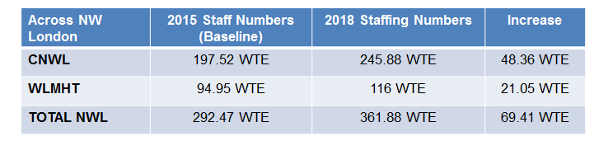

Since the transformation plan was implemented in 2015 the total WTE staffing has increased by 69.41 WTE.

CYP Improving Access to Psychological Therapies
The table below detail the number of additional CYP IAPT trainings that have been undertaken by staff since the start of the LTP. In response to the 5YFV target to increase the number of staff being trained by an additional 3,400 by 2020/21, the estimated NW London ‘share’ of the additional staff attending training is 136 WTEs. Table below shows the current number of staff trained by WLMHT and CNWL.

CYP IAPT Trained Staff in NW London
Provider | No of staff trained in CYP IAPT 2016/17 | No of staff trained in CYP IAPT 2017/18
CNWL | 21 | 9
WLMHT | 12 | 15

To achieve the proposed expansion in access to high quality mental health care for children and young people, a significant number of additional staff will be required. It is estimated nationally an additional 1,700 more therapists and supervisors will be required. Across NW London this equates to 68 additional staff. Of the 68 approximately three quarters is expected to be therapists and one quarter supervisors. Number of managers supervisors have undertaken CYP IAPT Leadership/Management and Supervision courses and the recruitment of further staff to commence training in 2018 and 2019 are underway.

The table below shows the progress has been made in workforce expansion through recruit to train and children’s wellbeing practitioner.
Staff | Brent | Central  London | Ealing | H&F | Harrow | H’don | H’slow | West London
RTT | 1 | 1 | 2 | 0 | 1 | 1 | 0 | 1
CWP | 0 | 0 | 4.5 | 6 | 0 | 0 | 6.5 | 0

Trusts are thinking creatively to use the skill mix and the unregistered and volunteer workforce to develop career pathways and opportunities for these groups to be retained and to support them to progress their planned careers. A CAMHS skills mix forum will be launched to identify and address the on-going needs of skill mix staff. The CWP programme is continuing to be success following the pilot period resulting in retention of staff and identifying further staff for training.

6.2.3 Next Steps
- identify the areas of the children’s mental health workforce (CAMHS targeted and specialist) where additional capacity is required in order to increase access to evidence-based interventions for specific mental health needs, and identify the resources required to create such capacity,
- undertake a workforce needs assessment in relation to the non-CAMHS workforce, including schools, colleges, voluntary and community sector, to understand where there is a need to develop capacity and capability, through workforce development approaches such as training, shadowing and consultation from professionals, and develop a plan to address the needs identified,
- complete workforce audit and needs assessments and develop a workforce strategy setting out long, medium and short term plans to achieve implementation of the THRIVE model and culture change required,
- work with regional colleagues through the Strategic Clinical Network and including Health Education North West London to develop strategic approaches to increase capacity where there are hard to recruit to posts,
- engage with Association of Directors of Children Services to develop a strategic and consistent approach in engaging with schools and colleges,
- support Trusts in mobilising and embedding recruitment, retention and training plans,
- identify local funding streams to embed CYP IAPT training as the national funding tails off.

6.3 Enabler Three: Performance Monitoring and Reporting

6.3.1 Our Ambition
Our service commissioning and re-design is underpinned by the systematic collection, analysis and reporting of robust activity and outcomes data that demonstrate the reach, responsiveness and impact of commissioned service.

We will have a monitoring framework that captures outcome, goal-based, measures, activity against agreed targets (e.g. referral, access, waiting times and DNAs) and patient experience data to facilitate discussion between commissioners and clinicians about service improvement and development opportunities, demand management, appropriateness of referrals, throughput and case closure.

We will actively monitor our services through national and local data so that we can be confident that we know what good looks like and take action when services are of low quality, and disseminate and promote evidence based practice, pathways and information across NW London.

6.3.2 Progress
In order to plan across a broader footprint we are working with our providers to develop data sets for local reporting on key indicators, including quality indicators. Each provider uses a different system and has different reporting and monitoring arrangements with commissioners. As part of the wider Mental Health Programme, a decision has been made to ascertain a shared dataset and develop a consistent performance dashboard to monitor progress towards realisation of our ambitions and to facilitate benchmarking and data aggregation to support planning across the NW London footprint. This work is in early stages and a phased approach will be adopted. Later stages of the development will also interface with other providers, local authority, voluntary sector etc, to take into consideration of the system resilience, access levels and patient experience.

We recognised that our current performance monitoring and contract management arrangements have been overseen by various teams and whilst this is adequate for all its intents and purposes, there is an improvement opportunity to bring these activities together to have far greater understanding of demand, patterns, and provide a mechanism to better monitor activity and performance across multiple providers, both for borough and NW London level.

6.3.3 The Next Steps
- agree a set of activity, performance and quality metrics and key performance indicators to form the NWL dashboard to support effective, consistent and comparable monitoring progress towards expected outcomes,
- drive significant improvements in performance, requiring providers to demonstrate the achievement of better outcomes and value for money, and holding them to account where they are failing to meet agreed outcome, output and quality targets.

7. Governance and Risks
The bi-monthly CAMHS Steering Group oversees the transformation programme and supports the development of this plan. It brings together the key representatives from across NW London including Commissioners, GP Clinical Leads, young people and their families, clinicians and management from CNWL and WLMHT, local authority, Healthy London Partnership and NHSE Colleagues.

The Steering Group reports formally to the NWL Mental Health and Wellbeing Transformation Board – which is accountable to its constituent CCGs and Health and Wellbeing Boards. The Board is multi-agency and has oversight of the entirety of mental health and wellbeing strategic development across NW London.

In addition 3 dedicated multi-agency implementation groups are in place to support the implementation of the programme:

- The bi-monthly WLMHT Implementation Group which includes associated CCGs: Ealing, Hammersmith & Fulham and Hounslow, GP Clinical Leads and WLMHT clinicians and management team.
- The bi-monthly CNWL Implementation Group which includes associated CCGs: Brent, Central London, Harrow, Hillingdon and West London GP Clinical Leads and CNWL clinicians and management team.
- The bi-monthly Clinician to Clinician forum has a themed programme and engages a wide range of clinical representatives from across the system including paediatric, A&E, CAMHS, AMHS, Health London Partnership Learning Disability and Autism colleagues. The forum aims to provide clinical advice and expertise to the Children and Young People’s (CYP) Mental Health and Wellbeing Programme.

As well as reporting to the Steering Group, these groups have a clear link to local governance structures in CCG’s and local authorities. Diagrammatic representation of the governance structure is set out on page 54.

Our over-arching governance model links the NWL Mental Health and Wellbeing Strategy with the 8 NWL CCGs and Local Authorities, with clear governance and reporting to ensure shared ownership of delivery of our transformation plans.

In developing our plans we have established a clear governance structure at the NWL level. We also know that transformation predominately happens at local level. Each CCG has a clear structure for engaging different agencies in delivering change – these ensure connections to local decision making bodies in CCGs and Local Authorities as well as the right links to wider children’s work and mental health developments. The Transformation Board at a NWL level has NHS England representation providing a clear link to specialist commissioning and Health in Justice Teams.

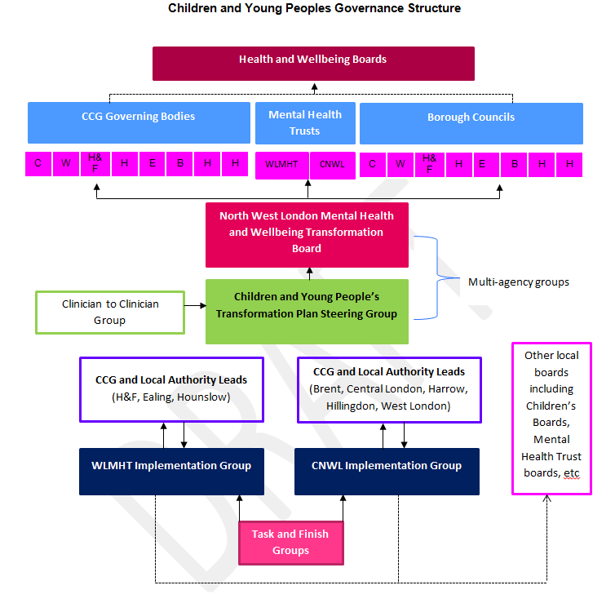

8. Risk Management
Key risks specific to the plan are set out below alongside the associated mitigating action.

RISK REGISTER
 | Description | Impact | Inherent  Risk  Rating | Avoidance / Mitigation | Residual Risk Rating
R1 | Lack of capacity and capability required to meet service requirements and implementation of new ways of working | Service delivery would be at risk due to vacancies and waiting lists would increase also impacting on the recovery of the young person. There could also be delays in implementing aspects of the new model. | 16 | A workforce strategy is in development which sets out the plans to ensure the wider CYP workforce have the right skills to deliver the right intervention at the right time. We are aligning to National HEE education and training directives and implementing designated initiatives across NW London. Trusts are developing career pathways and identify new routes for entry into the profession. | 12
R2 | Lack of accurate and timely data | Inability to understand performance and demonstrate outcome, cost and quality impact new services and new ways of working will bring | 12 | Development of a dashboard to demonstrate current activity levels and allow for monitoring of impact of the new service delivery framework. | 6
R4 | Lack of salary support to roll out CYP IAPT | Inability to recruit staff to train due to financial pressures that this would create. | 12 | Discussion and planning is underway. Linking in with the wider impact analysis of increasing IAPT workforce with HEE and NHSE. | 9
R5 | Limited buy in, capacity and engagement from other agencies e.g. education and local authority. | Difficulty developing, new ways of working and new pathways | 12 | Development of a communication and engagement strategy to ensure wider sector are aware of benefits and risks of the change | 6

9. Local Annexes

ANNEX A: Brent CCG (attached as a separate document)

ANNEX B: Central London CCG (attached as a separate document)

ANNEX C: Ealing CCG (attached as a separate document)

ANNEX D: Hammersmith and Fulham CCG (attached as a separate document)

ANNEX E: Harrow CCG (attached as a separate document)

ANNEX F: Hillingdon CCG (attached as a separate document)

ANNEX G: Hounslow CCG (attached as a separate document)

ANNEX H: West London CCG (attached as a separate document)

NW London Sustainability and Transformation Plan November 2016 https://www.healthiernorthwestlondon.nhs.uk/sites/nhsnwlondon/files/documents/nwl_stp_october_submission_summary_v01.pdf
THRIVE Elaborated. Wolpert et al 2016 http://www.annafreud.org/service-improvement/service-improvement-resources/thrive/1
National Statistics January 2018 Special educational needs in England: January 2018 Local authority tables: Table 12 - https://www.gov.uk/government/statistics/special-educational-needs-in-england-january-2018
Office for National Statistics– Mid 2017 dataset – https://www.ons.gov.uk/peoplepopulationandcommunity/populationandmigration/populationestimates/datasets/populationestimatesforukenglandandwalesscotlandandnorthernireland
4 Office for National Statistics– Mid 2017 dataset – https://www.ons.gov.uk/peoplepopulationandcommunity/populationandmigration/populationestimates/datasets/populationestimatesforukenglandandwalesscotlandandnorthernireland ? Health London Partnership – Executive Mental Health Dashboard for London
Public Health England Fingertips – Children and Young People’s Mental Health and Wellbeing - https://fingertips.phe.org.uk/profile-group/mental- health/profile/cypmh/data#page/1/gid/1938133090/pat/120/ati/153/are/E38000020
Mental Health Foundation – self harm - htps://www.mentalhealth.org.uk/a-to-z/s/self-harm
Public Health Profiles – Looked After Children where there is a cause for concern-https://fingertips.phe.org.uk/search/looked%20after%20children
National Statistics, Special educational needs in England: January 2018 Local authority tables:SFR37/201 https://www.gov.uk/government/statistics/special-educational-needs-in-england-january-2018
https://fingertips.phe.org.uk/cypmh#page/0/gid/1938133096/pat/6/par/E12000007/ati/102/are/E09000005/iid/10401/age/211/sex/4
Excluding Harrow Horrizon Tier 2 voluntary sector acceptance numbers and rates
Data provided is a snapshot of June 2017 to enable year on year comparison
THRIVE 2016- http://www.annafreud.org/service-improvement/service-improvement-resources/thrive/1
Apr 2017 to Dec 2018 children and young people were seen by the ‘Out of Hours’ Services and from Jan-Apr 2018 by the new Integrated Crisis Services
Drawing on the Evidence (Second Edition), Wolpert, Fuggle, Cottrell et al. (2006) CAMHS Publications
The numbers reported here are staff currently retained from previous waves of training.

